# Revature Consultancy Private Ltd.

# Revature - Wikipedia

**A**

## Project Report On

## “Administrating and Implementing Windows Server 2016

## In an AWS Cloud Infrastructure”

**Submitted By:**

|  |  |
| --- | --- |
| **Sr. No.** | **Name** |
| **1** | Mr. Prajwal Nimkarde |
| **2** | Mr. Harshal Patil |
| **3** | Mr. Deepankar Samantha |
| **4** | Ms. Rani Behare |
| **5** | Ms. Sakshi Shaha |
| **6** | Ms. Gauri Vetal |
| **7** | Ms. Renuka Chavan |

**Under the Guidance of**

**Mr.Zakir Hussain**

**Acknowledgement**

We, the project group, would like to express our sincere gratitude to everyone who supported us throughout the completion of this project, Administering and Implementing Windows Server 2016 in AWS Cloud Infrastructure.

First and foremost, we would like to thanks **Mr. Zakir Hussain** for their invaluable guidance, mentorship, and encouragement throughout the project. Their expert advice and insightful feedback were crucial in helping us navigate the challenges we encountered.

We are also grateful to **Revature Consultancy Private Ltd.** for providing the necessary resources and infrastructure, enabling us to explore the practical applications of Windows Server administration in a cloud environment. The tools and facilities made available to us were vital for the successful execution of the project.

A special thanks to our teammates, for their dedicated efforts, teamwork, and collaboration. Each member’s contributions, whether in research, planning, or implementation, were essential in bringing this project to fruition.

We also appreciate the support and cooperation of our colleagues and peers who provided constructive feedback during the course of the project. Their input helped us improve the quality of our work.

Thank you all for your contributions and support, which have made this group project a success.

**Abstract**

Cloud computing has transformed the way organizations manage their IT environments, offering enhanced flexibility, scalability, and cost-effectiveness. This project explores the process of deploying and administering Windows Server 2016 within the Amazon Web Services (AWS) Cloud Infrastructure, highlighting the integration of Windows Server’s enterprise-level features with AWS's powerful cloud services.

The project involves creating a robust cloud infrastructure by configuring AWS EC2 instances, setting up a Virtual Private Cloud (VPC), and implementing key Windows Server roles such as Active Directory Domain Services (AD DS) for identity and access management. Additionally, it addresses essential security measures, including the configuration of AWS Identity and Access Management (IAM) roles and security groups to ensure safe and secure operations in the cloud environment. The project also outlines the use of AWS CloudWatch for continuous performance monitoring and resource optimization, as well as AWS Backup for data protection and disaster recovery.

By overcoming various challenges related to cloud setup, resource allocation, and security, this project showcases the practical aspects of running Windows Server 2016 on AWS. It provides a roadmap for efficiently managing cloud-hosted Windows servers, ensuring that the system is scalable, secure, and cost-effective. The findings of this project serve as a useful guide for organizations seeking to transition their IT operations to the cloud while maintaining control over critical infrastructure.

**Index**

|  |  |  |
| --- | --- | --- |
| **Sr. No.** | **Title** | **Page No.** |
| 1 | Introduction | 1 |
| 3 | Problem Statement | 3 |
| 4 | Need of Work | 4 |
| 5 | Objectives | 6 |
| 6 | Proposed Work | 7 |
| 7 | Technologies | 9 |
| 8 | System Architecture | 11 |
| 9 | System Requirements | 12 |
| 10 | Implementation and Results | 14 |
| 11 | Real Time Scenario | 48 |
| 12 | Conclusion | 49 |
| 13 | Future Scope | 50 |

**Introduction**

This project focuses on the administration and implementation of Windows Server 2016 in an AWS Cloud environment. AWS (Amazon Web Services) provides scalable, secure, and highly available cloud infrastructure to manage and deploy Windows Server instances, enabling enhanced operational efficiency, cost optimization, and security. The project involves setting up core Windows services like Active Directory Domain Services (AD DS), DNS, DHCP, and Web Server on EC2 instances, along with robust backup and monitoring mechanisms for managing cloud operations. The goal is to create a reliable, secure, and scalable infrastructure to host Windows Server workloads, with automated monitoring, disaster recovery, and secure network configurations.

**AWS Services Used**

1. EC2 (Elastic Compute Cloud): EC2 instances form the core of the infrastructure where Windows Server 2016 is hosted. These virtual machines provide scalable compute resources necessary for deploying critical Windows Server services such as AD DS, DNS, DHCP, and web servers.

2. VPC (Virtual Private Cloud): A Virtual Private Cloud is used to create a secure, isolated environment for Windows Server deployment. Subnets are configured to segment the network into private and public zones, ensuring that sensitive resources are accessible only via controlled methods.

3. EBS (Elastic Block Store): EBS provides durable storage volumes attached to EC2 instances. It is used for file storage and as a persistent storage solution for server data, application data, and backups.

4. AMI (Amazon Machine Image): AMIs are used to create customized, pre-configured images of the Windows Server setup, allowing for easy replication of the server environment across multiple instances.

**Windows Server Components Installed**

1. Active Directory Domain Services (AD DS): AD DS is set up on the Windows Server to manage user identities, groups, and access controls. It provides centralized user authentication and authorization services across the network.

2. DNS (Domain Name System): DNS is deployed for resolving domain names to IP addresses within the network, essential for the functioning of AD DS and communication between networked systems.

3. DHCP (Dynamic Host Configuration Protocol): DHCP is used to automatically assign IP addresses to devices within the VPC, simplifying network management and reducing manual IP configuration.

4. Web Server: IIS (Internet Information Services) is installed to host and manage websites and web applications on the server. It allows secure access to hosted applications via public-facing EC2 instances.

5. File Storage: A dedicated file storage server is configured using EBS volumes to provide network-attached storage for users and applications.

**Backup and Recovery**

1. Windows Backup: Windows Backup is configured on the server to automate the backup process of critical system files and data, ensuring data integrity in case of failure.

2. EBS Snapshots: EBS snapshots are taken regularly to capture point-in-time backups of EBS volumes attached to EC2 instances. These snapshots provide a quick disaster recovery solution.

3. AMI: Custom AMIs are created to save the current state of the Windows Server configuration, allowing for easy replication and recovery in case of system failure.

**Security and Networking**

1. Firewall and Security Groups: AWS Security Groups are configured to control inbound and outbound traffic to EC2 instances. This acts as a virtual firewall, ensuring that only authorized traffic is allowed to specific resources.

2. IAM (Identity and Access Management): IAM policies are configured to provide fine-grained access control to AWS resources, ensuring that only authorized personnel can access sensitive resources.

**Monitoring and Event Logging**

1. CloudWatch: AWS CloudWatch is used to monitor the performance of EC2 instances and other AWS resources. It tracks CPU utilization, memory usage, disk activity, and other performance metrics.

2. CloudTrail: AWS CloudTrail logs all API calls and actions taken within the AWS environment. It is crucial for auditing and tracking user activities to ensure compliance and security.

3. Windows Performance Monitor: This built-in tool is used to track system performance metrics on the Windows Server, including CPU, memory, disk, and network usage.

4. Event Viewer: Windows Event Viewer logs critical system and security events, aiding in troubleshooting and ensuring system stability.

**Problem Statement**

As organizations migrate their IT infrastructure to the cloud, effectively deploying and managing Windows Server 2016 in Amazon Web Services (AWS) presents several challenges. Key issues include configuring AWS resources to meet performance needs, ensuring robust security measures, integrating essential Windows Server roles like Active Directory and DNS, and maintaining ongoing monitoring and cost management.

This project addresses the complexity of these challenges, providing a structured approach to successfully implement and administer Windows Server 2016 within AWS. By doing so, it aims to empower organizations to leverage cloud capabilities while maintaining control and efficiency in their IT operations.

**Need of Work**

1. Scalability and Flexibility

- Leverage AWS EC2 to easily scale resources based on demand.

- Utilize VPC to customize networking and security configurations for Windows Server environments.

2. Cost Efficiency

- Pay-as-you-go pricing model of AWS allows for cost-effective management of resources.

- EBS provides persistent storage with optimized costs for different workloads.

3. High Availability and Reliability

- Deploy Windows Server 2016 components in multiple Availability Zones for redundancy.

- Use AMI for rapid deployment and recovery of server instances.

4. Integrated Backup and Recovery Solutions

- Implement Windows Backup and EBS Snapshots for reliable data protection and recovery.

- Utilize AMIs for quick restoration of server configurations and applications.

5. Enhanced Security and Compliance

- Configure firewall and security groups for robust network security.

- Utilize IAM for fine-grained access control and management of user permissions.

6. Efficient Networking

- Implement DHCP automated IP address management.

- Set up DNS to facilitate name resolution within the network.

7. Monitoring and Performance Management

- Utilize CloudWatch for real-time monitoring of system performance and resource utilization.

- Leverage CloudTrail for auditing and tracking API calls for compliance.

- Used for in-depth analysis of system health.

8. Active Directory Integration

- Deploy AD DS to centralize user management and authentication.

- Facilitate group policy management for consistent configuration across the environment.

9. Web Hosting and File Storage

- Utilize the Web Server role for hosting applications and services.

- Implement File Storage solutions for centralized data management and accessibility.

This outline highlights the key benefits and functionalities of implementing Windows Server 2016 within an AWS cloud infrastructure.

**Objectives**

* To proficiently administer and implement Windows Server 2016 in an AWS cloud infrastructure by leveraging cloud-based tools and services for optimized performance, scalability, and security.
* Ensure seamless integration of Windows Server with AWS services such as EC2, VPC, and IAM, enabling efficient server management, data backup, and recovery.
* Focus on automating deployments, monitoring server performance, and enhancing security using AWS Identity and Access Management policies and AWS CloudWatch.
* Continuously adapt to best practices for cost optimization and resource management within a cloud-based environment.

**Proposed Work**

1. Infrastructure Setup

- Provision EC2 Instances: Launch Windows Server 2016 instances using AMIs that meet the application requirements.

- Configure VPC: Design a Virtual Private Cloud to segment the network, ensuring secure communication and resource allocation.

2. Windows Server Component Installation

- Active Directory Domain Services (AD DS): Install and configure AD DS to manage users, groups, and resources within the domain.

- DNS Configuration: Set up and configure DNS to support name resolution within the VPC, ensuring proper connectivity for all services.

- DHCP Configuration: Implement DHCP to automatically assign IP addresses to instances within the VPC, simplifying network management.

- Web Server Deployment: Install and configure IIS to host web applications, ensuring proper security settings and performance optimizations.

- File Storage Setup: Configure file shares and permissions for efficient file management and access across the organization.

3. Backup and Recovery Solutions

- Windows Backup Configuration: Implement Windows Backup for backing up system data and applications to ensure data integrity and recovery options.

- EBS Snapshots: Schedule regular EBS snapshots to capture the state of volumes, facilitating point-in-time recovery.

- Create AMIs: Develop custom AMIs to streamline the deployment of new instances and ensure consistency across environments.

4. Security and Networking Configuration

- Firewall and Security Groups: Configure security groups and network ACLs to control inbound and outbound traffic, enhancing security.

- IAM Roles and Policies: Set up IAM roles and policies to manage permissions for users and services accessing the AWS environment securely.

5. Monitoring and Event Logging

- CloudWatch Implementation: Set up CloudWatch for monitoring resource utilization, performance metrics, and setting alarms for critical thresholds.

-CloudTrail Configuration: Enable CloudTrail for logging API calls, ensuring compliance and auditing capabilities.

- Windows Performance Monitor and Event Viewer: Utilize these tools for ongoing performance monitoring and troubleshooting of Windows Server issues.

This structured approach outlines the key areas of work needed for successfully administering and implementing Windows Server 2016 in an AWS cloud infrastructure, ensuring efficient operations and management.

**Technologies**

1. Amazon EC2 (Elastic Compute Cloud)

- A web service that provides resizable compute capacity in the cloud, allowing users to launch and manage virtual servers running Windows Server 2016.

2. Amazon VPC (Virtual Private Cloud)

- A service that enables users to provision a logically isolated section of the AWS cloud, where they can define and control a virtual network, including IP address range, subnets, and route tables.

3. Amazon EBS (Elastic Block Store)

- Provides block-level storage volumes for use with EC2 instances, offering durability, availability, and performance for applications that require consistent and low-latency access to data.

4. Amazon AMI (Amazon Machine Image)

- A pre-configured template that contains the operating system, application server, and applications required to launch an EC2 instance, facilitating rapid deployment and scaling of server resources.

5. Windows Server 2016

- The server operating system used to manage server resources, applications, and services, featuring enhanced security, virtualization capabilities, and support for cloud integration.

6. Active Directory Domain Services (AD DS)

- A Windows Server feature that provides a centralized directory service for managing user accounts, computer accounts, and security policies within a network domain.

7. DNS (Domain Name System)

- A service that translates domain names into IP addresses, allowing users to access resources on the network using human-readable names.

8. DHCP (Dynamic Host Configuration Protocol)

- A network protocol that automatically assigns IP addresses and other network configuration parameters to devices on a network, simplifying the process of connecting devices to the network.

9. IIS (Internet Information Services)

- A web server role in Windows Server that provides a secure and manageable platform for hosting websites, web applications, and services.

10. Windows Backup

- A backup solution integrated into Windows Server that allows administrators to back up system state, applications, and data, providing recovery options in case of data loss.

11. Amazon CloudWatch

- A monitoring service that provides real-time visibility into resource utilization and operational performance, enabling proactive management of AWS resources.

12. Amazon CloudTrail

- A service that enables governance, compliance, and operational and risk auditing of AWS accounts by logging and monitoring API calls made in the account.

13. Windows Performance Monitor

- A tool that provides detailed metrics and performance data about system resources, applications, and services running on Windows Server, assisting in troubleshooting and optimization.

14. Event Viewer

- A built-in Windows tool that allows administrators to view and analyze event logs for various system and application events, aiding in monitoring and troubleshooting.

15. AWS Identity and Access Management (IAM)

- A web service that helps users securely control access to AWS services and resources, allowing for the creation of user accounts, roles, and policies to manage permissions.

**System Architecture**

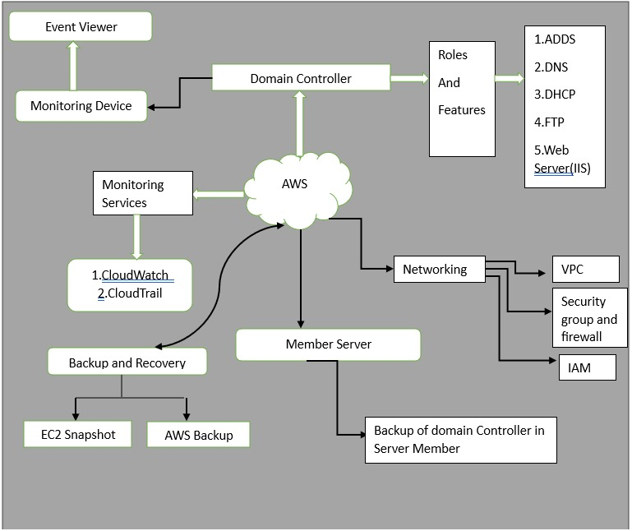

Fig:Architecture Diagram of proposed System

**System Requirements**

**1. Hardware Requirements**

**For AWS EC2 Instance Running Windows Server 2016:**

- Instance Type:

- Minimum: t2.medium

2 vCPUs

4 GiB RAM

- Storage:

- EBS (Elastic Block Store):

- Minimum: 30 GiB of General Purpose SSD (gp2) or Provisioned IOPS SSD (io1).

- Additional storage may be required based on application needs and data storage.

**For Local Management Machine:**

- Processor:

- 2 GHz dual-core processor (or faster recommended).

- Memory:

- Minimum: 4 GB RAM (8 GB or more recommended for smoother performance).

- Hard Disk Space:

- Minimum: 20 GB of free disk space for installation of management tools and software.

- Network Adapter:

- A network adapter capable of supporting high-speed Internet access for RDP and AWS management.

**2. Software Requirements**

**For AWS EC2 Instance Running Windows Server 2016:**

- Operating System:

- Microsoft Windows Server 2016 Core Base

- Windows Features:

- Active Directory Domain Services (AD DS)

- DNS Server

- File and Storage Services

- Web Server (IIS)

**For Local Management Machine:**

- Operating System:

- Windows 10 (64-bit) or later, or any compatible OS for RDP clients (Windows, macOS, or Linux).

- Remote Desktop Client:

- Microsoft Remote Desktop Client or similar software for RDP access.

- Web Browser:

- A modern web browser (e.g., Google Chrome, Mozilla Firefox, Microsoft Edge) for accessing the AWS Management Console.

- AWS Command Line Interface (CLI):

- Installation of the AWS CLI tool for managing AWS services through command line.

**3. Additional Software Tools**

- Monitoring Tools:

- AWS CloudWatch for monitoring EC2 instance performance.

- Backup Tools:

- AWS Backup for automating backup processes.

- Security Tools:

- Antivirus/Antimalware software for endpoint protection on the management machine.

**Implementation and Results**

**Deploying a Windows EC2 Instance and Connecting Using Remote Desktop (RDP)**

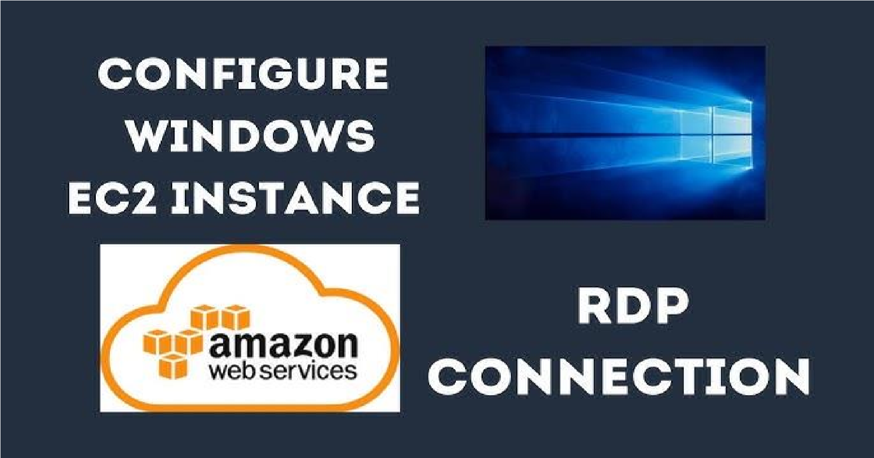

# Launch an EC2 Instance with Windows AMI

Step 1: Log in to AWS Management Console

* Go to the AWS Management Console.
* Log in with your credentials.

Step 2: Navigate to EC2 Dashboard

* In the AWS Management Console, search for EC2 in the search bar.
* Select EC2 to go to the EC2 Dashboard.

Step 3: Launch a New EC2 Instance

* Click the Launch Instances button.
* Enter a Name for your instance.

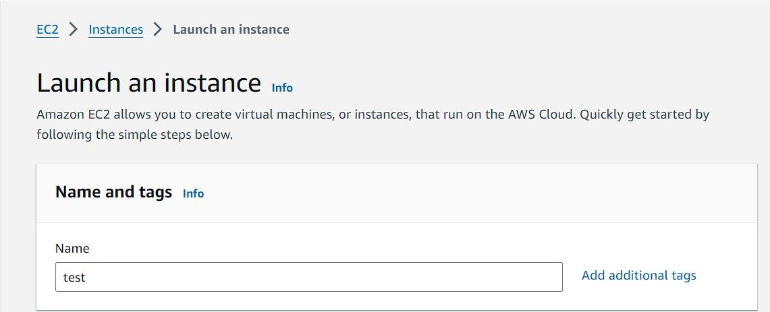

Step 4: Select a Windows AMI (Amazon Machine Image)

* In the Application and OS Images (Amazon Machine Image) section, click Browse more AMIs.
* Search for a Windows Server AMI (e.g., Windows Server 2019 or Windows Server 2022).

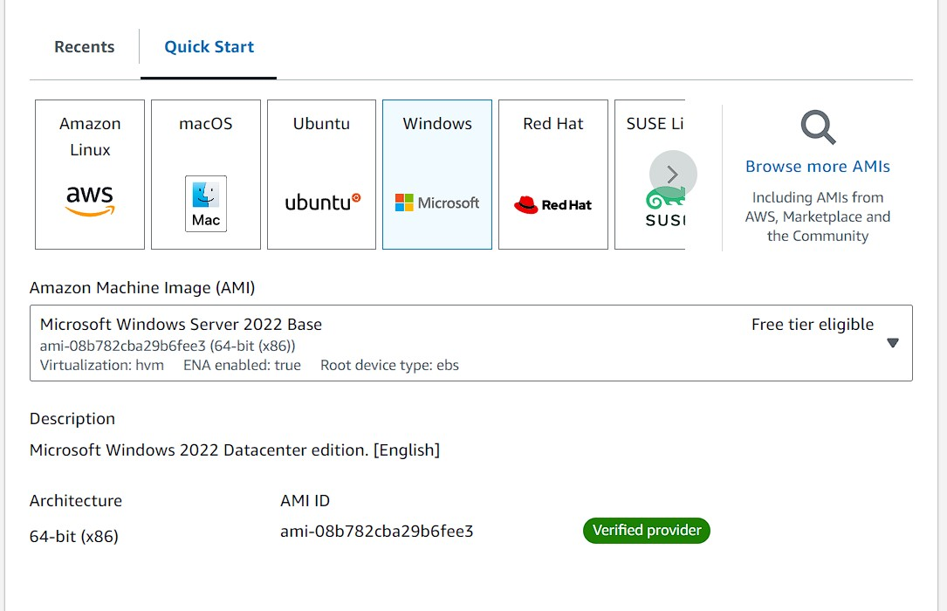

Step 5: Choose an Instance Type

* In the Instance type section, choose an instance type that supports Windows (e.g., t2.micro, which is free tier eligible).
* Click Next: Configure Instance Details (optional) or Review and Launch.

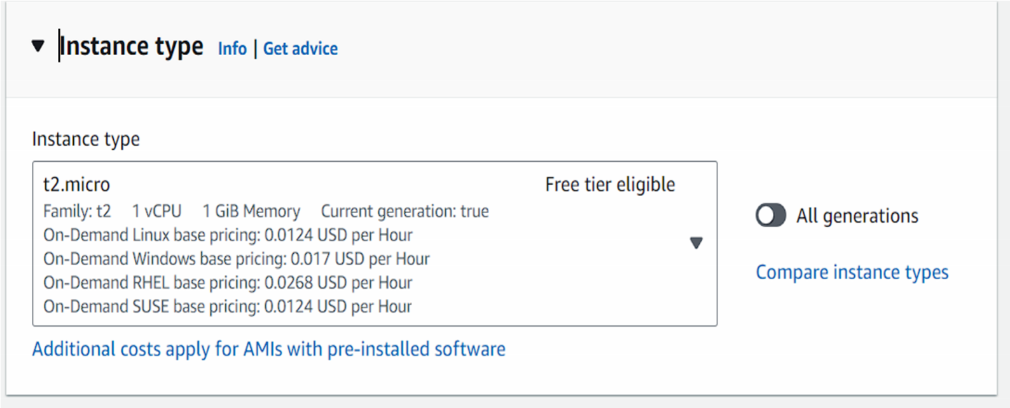

Step 6: Configure Key Pair for RDP Access

* Choose create a new key pair (or use an existing one if you already have it). Add Inbound Rules such as All ICMP-IPV4,RDP,SMB,HTTP,HTTPS,DNS(UDP),DNS(TCP).
* Download the .pem file of the key pair to your local machine.

This key will be needed to decrypt the password later.

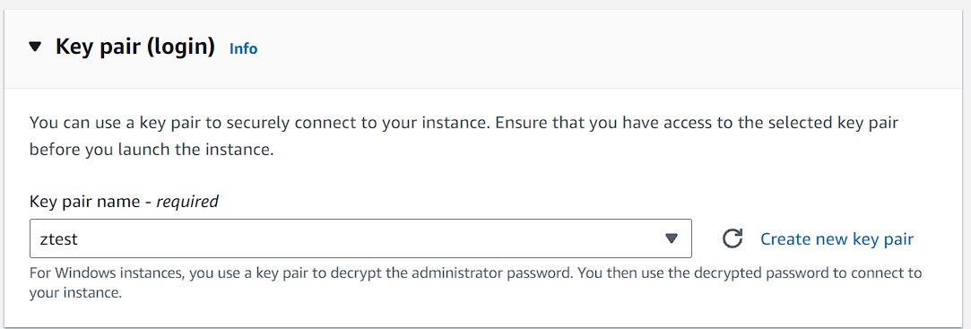

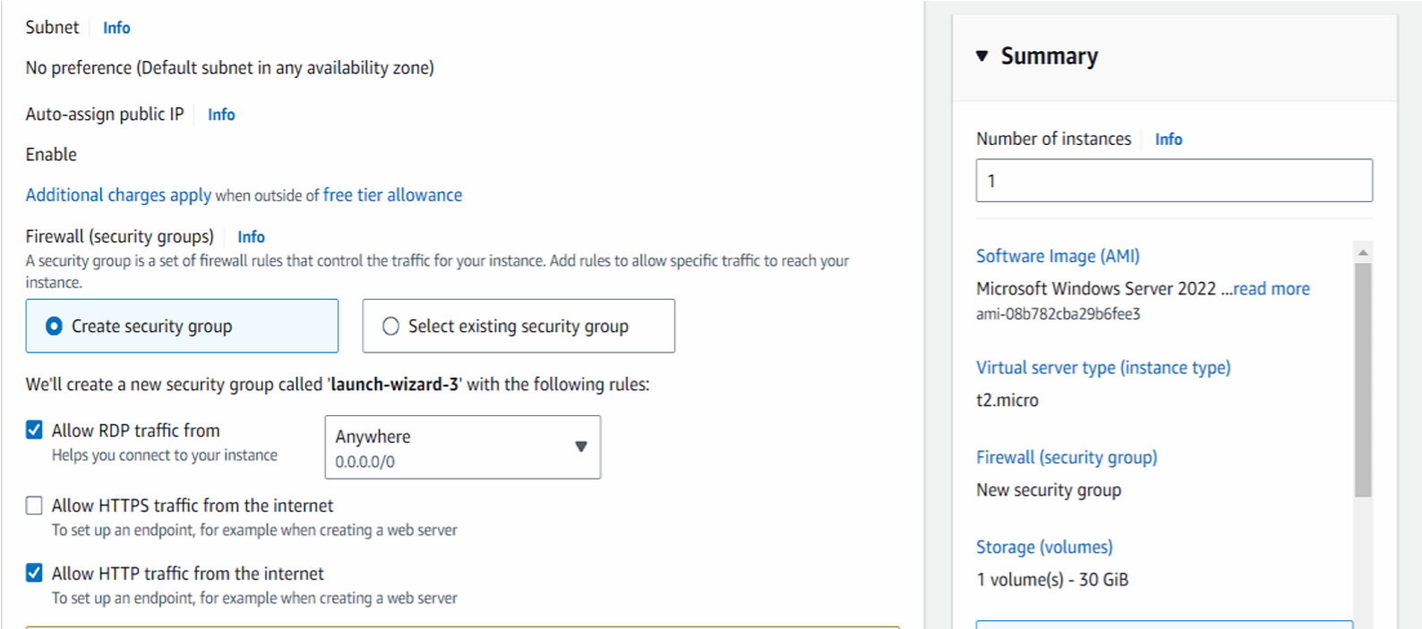

Step 7: Retrieve the Instance’s Public IP Address

* In the EC2 Dashboard, find your running instance.
* Copy the Public IPv4 address from the instance description. This will be used to connect to the instance.

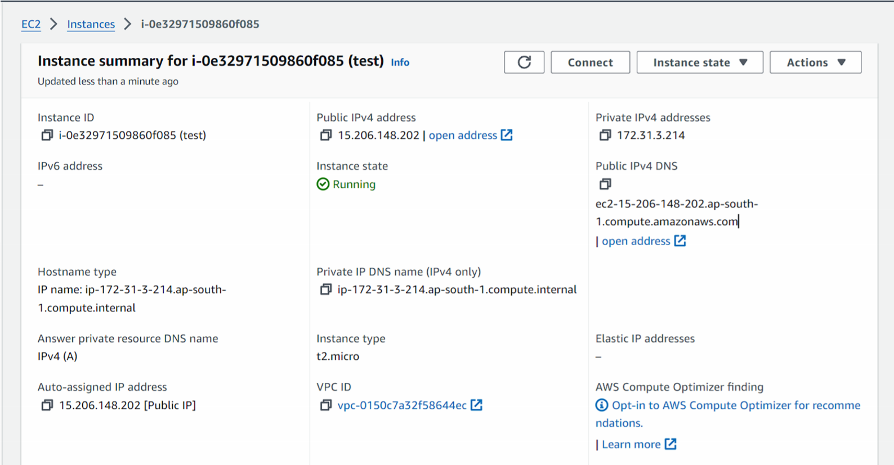

Step 8: Configure Network Settings

* + - Create a new security group to allow RDP connections:
    - RDP (Port 3389) - For connecting to the instance.
    - Set the source as Anywhere (0.0.0.0/0) or a specific IP range for security.

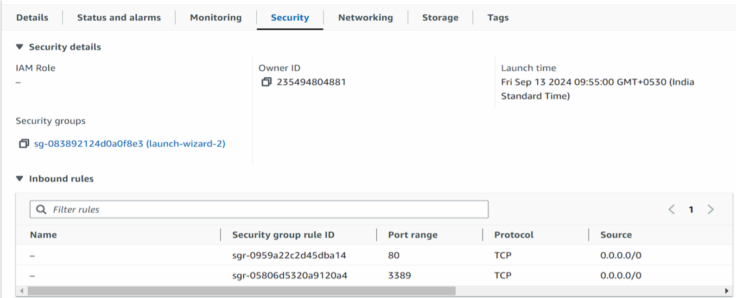

Step 9: Launch the Instance

* Review all the configurations and click Launch Instance.

Wait for the Instance to Start

* Go to the Instances page and wait until the instance status is Running.

Step 10: Get the Windows Password

* 1. Select your instance, click Connect at the top, and then choose the RDP Client tab.
  2. Click on Get Windows Password.
  3. Upload the private key file you downloaded when launching the instance to decrypt the password.

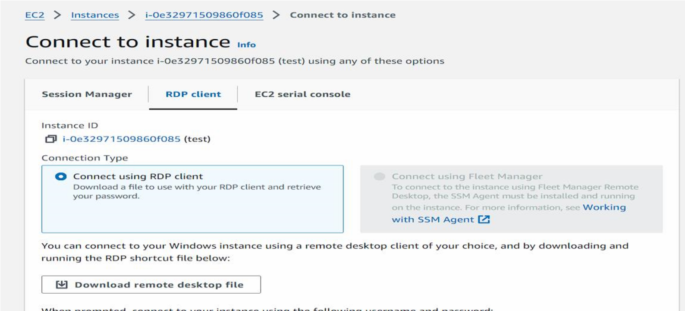

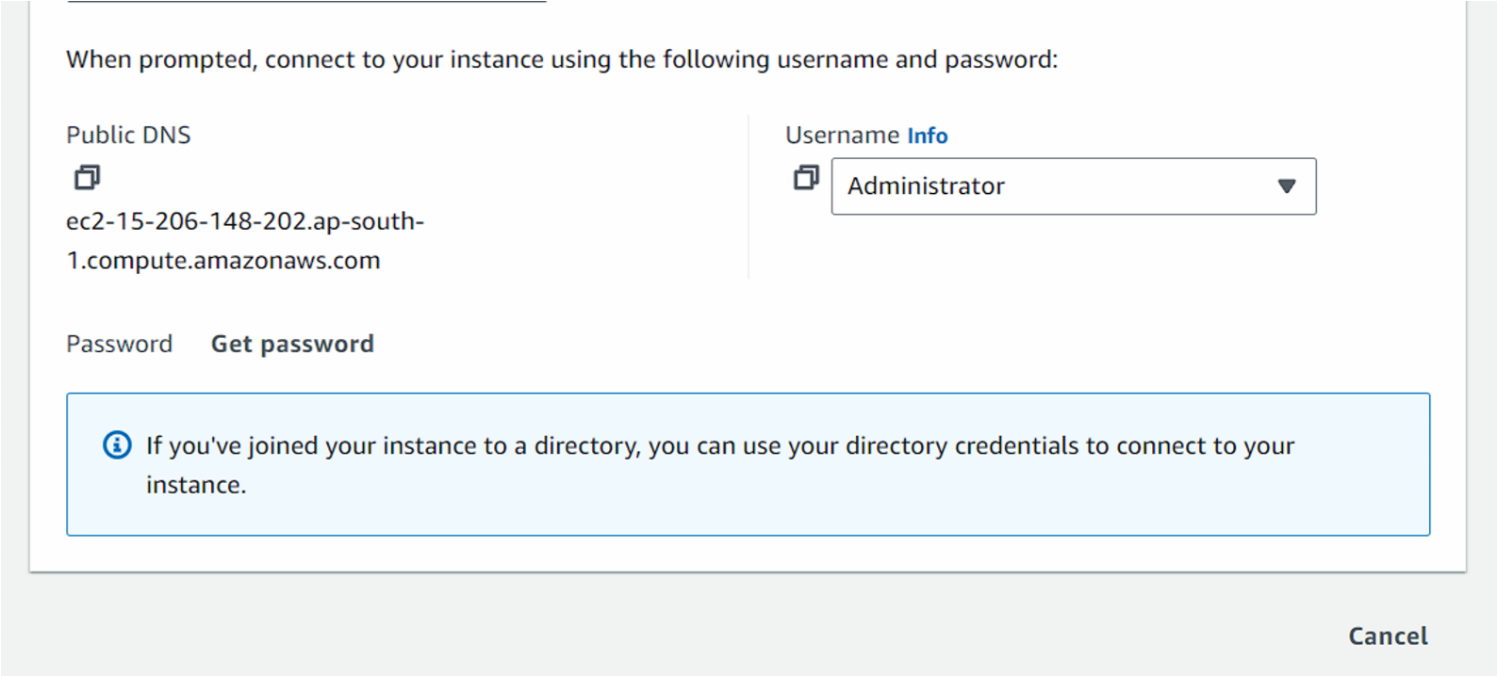

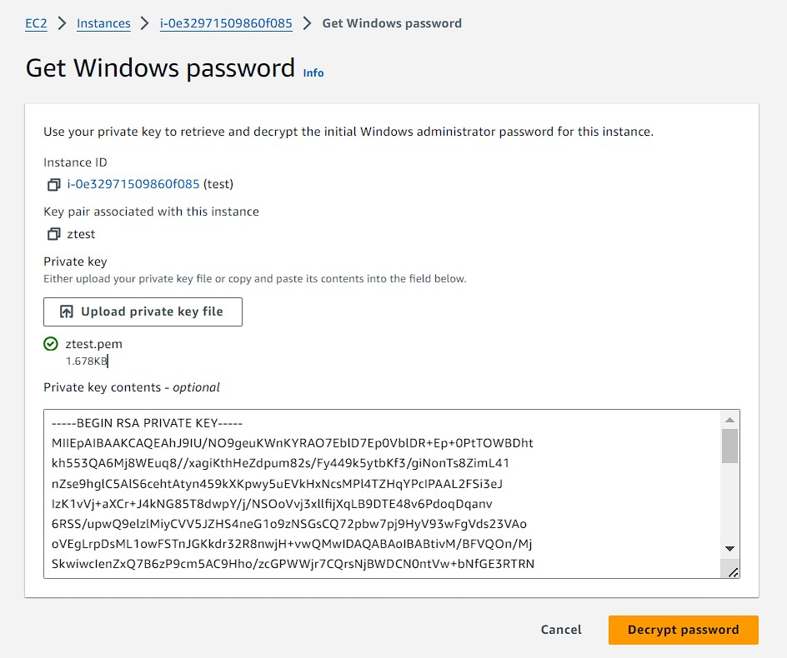

# Connect to the Windows Instance Using RDP

1. On your Windows desktop, search for Remote Desktop Connection.
2. Enter the Public DNS of the instance and click Connect.
3. Accept the security certificate by clicking Yes.

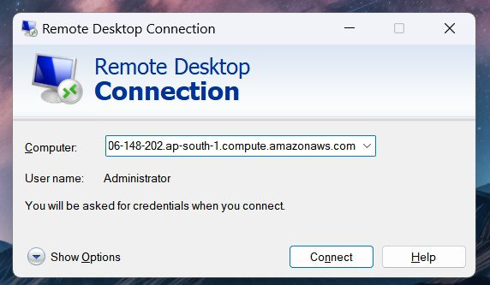

Enter Credentials

1. Enter the Username as Administrator and paste the decrypted password.
2. Click OK.

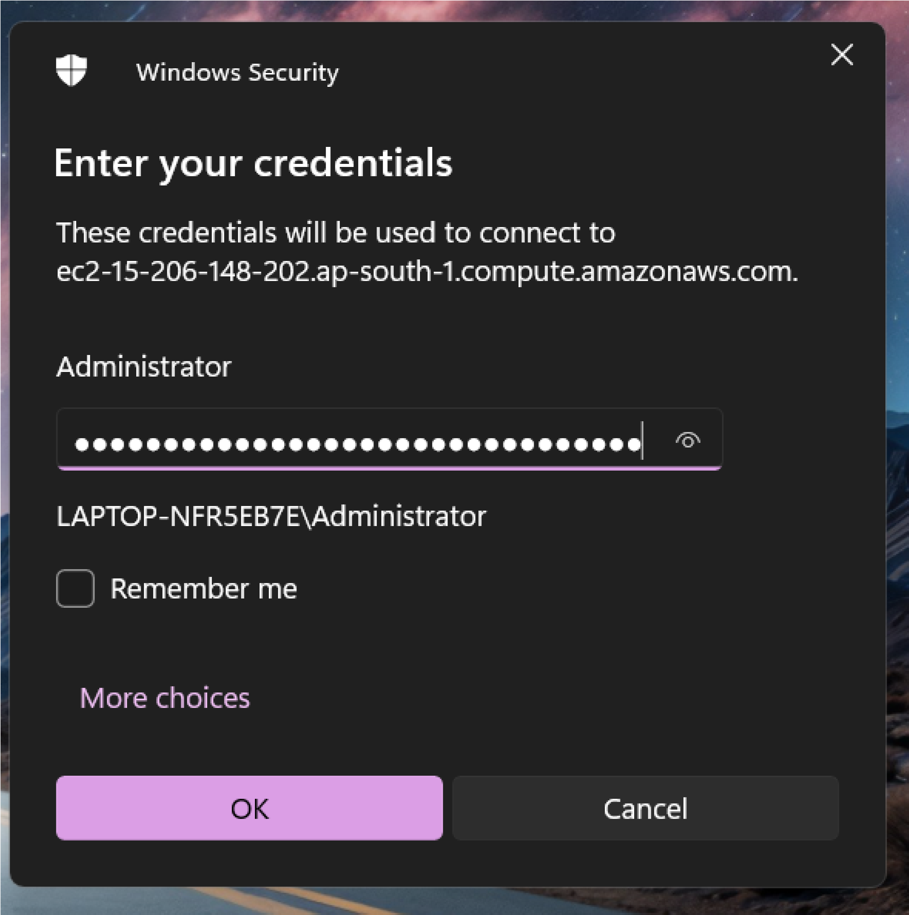

You’re connected!

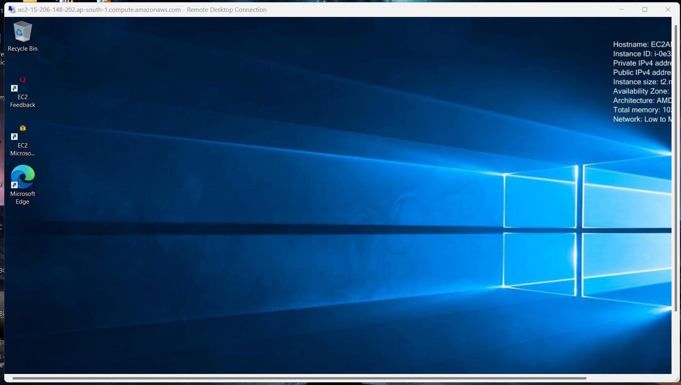

* **We have to create VPC(Virtual Private Network)**

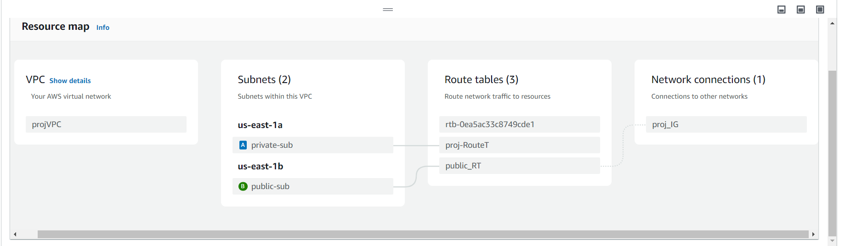

**After Creating and Launching two EC2 instances we have to go first to the Domain Controller and do the following installation of roles.**

**1. ADS:**

* **To install and implement Active Directory Domain Services (AD DS)** on a Windows Server 2016 instance running in AWS EC2, follow these steps:

**Step 1: Launch a Windows Server 2016 EC2 Instance**

1. Sign in to AWS Console and navigate to the EC2 Dashboard.

2. Launch a new EC2 instance:

- Choose Microsoft Windows Server 2016 Base as the Amazon Machine Image (AMI).

- Select the appropriate instance type (e.g., t2.medium for small AD environments).

- Configure security groups to allow:

- RDP (Remote Desktop Protocol) on port 3389 (for remote management)

- DNS on port 53

- LDAP (Lightweight Directory Access Protocol) on port 389 (for AD DS communication)

3. Launch the instance and download the private key (if needed).

**Step 2: Connect to the EC2 Instance**

1. Open your RDP client and connect to the Windows Server 2016 instance using the public DNS/IP of the EC2 instance and administrator credentials.

2. Once connected, ensure the server has been updated with the latest Windows updates.

**Step 3: Install the AD DS Role**

1. Open Server Manager:

- Click on Manage → Add Roles and Features.

- In the wizard, select Role-based or feature-based installation.

- Select the local server (your EC2 instance).

- Check the Active Directory Domain Services role.

- Click Add Features when prompted to install the required features.

- Click Next and then Install. Wait for the installation to finish.

**Step 4: Promote the Server to a Domain Controller**

1. After the AD DS role is installed, a notification will appear in Server Manager. Click Promote this server to a domain controller.

2. Choose to Add a new forest (if this is a new domain), and provide a root domain name (e.g., `example.com`).

3. Set the Domain Functional Level and Forest Functional Level to Windows Server 2016.

4. Set a Directory Services Restore Mode (DSRM) password.

5. Follow the prompts and leave the default selections unless you have specific requirements.

6. Complete the installation. The server will automatically reboot after the AD DS installation and configuration.

**Step 5: Configure DNS and Additional Settings**

1. Verify the DNS server settings:

- Ensure the server is pointing to itself for DNS resolution (`127.0.0.1` or `private IP`).

2. Configure security group rules:

- Make sure the security group attached to your EC2 instance allows DNS and AD-related traffic for other instances to communicate with this domain controller.

**Step 6: Testing ADDS**

1. After the server reboots, open Active Directory Users and Computers from Server Manager → Tools.

2. You can now create users, groups, and organizational units (OUs) as needed.

3. To test the domain:

- Launch another EC2 instance, and join it to the domain using the domain credentials.

- Use Active Directory Users and Computers to manage the domain.

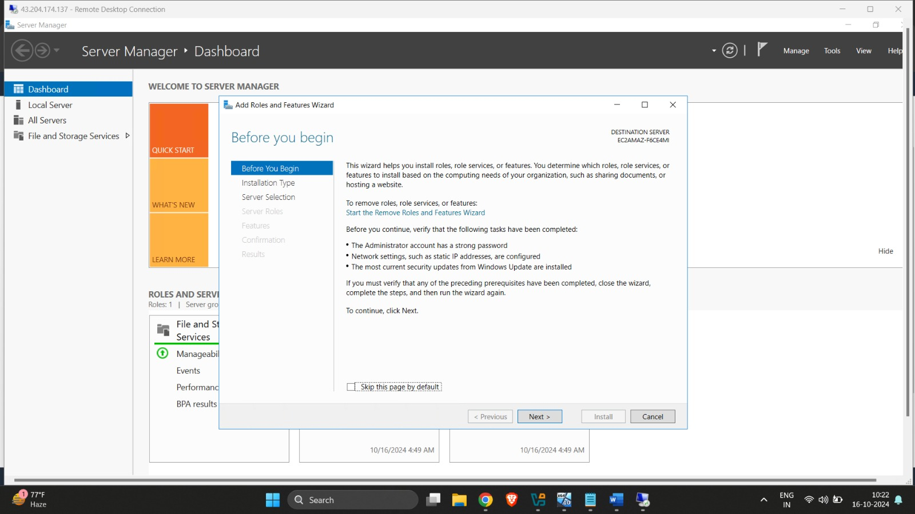

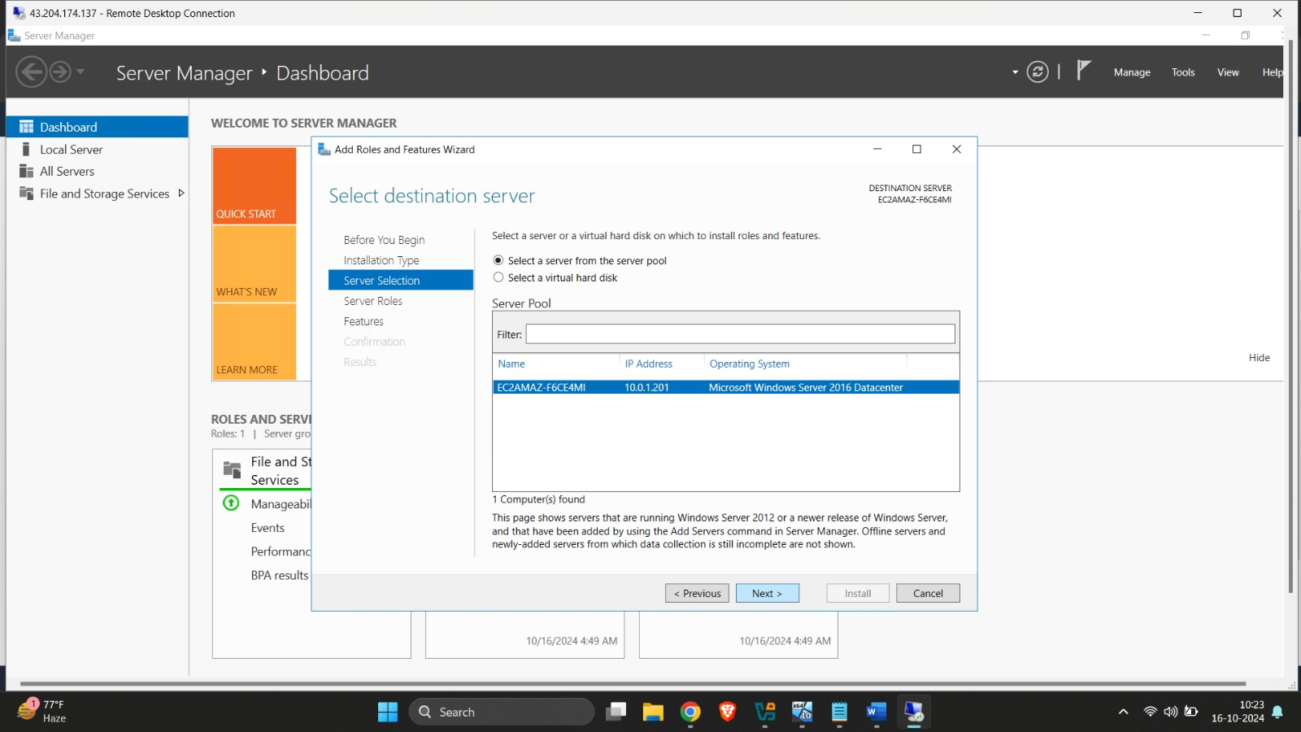

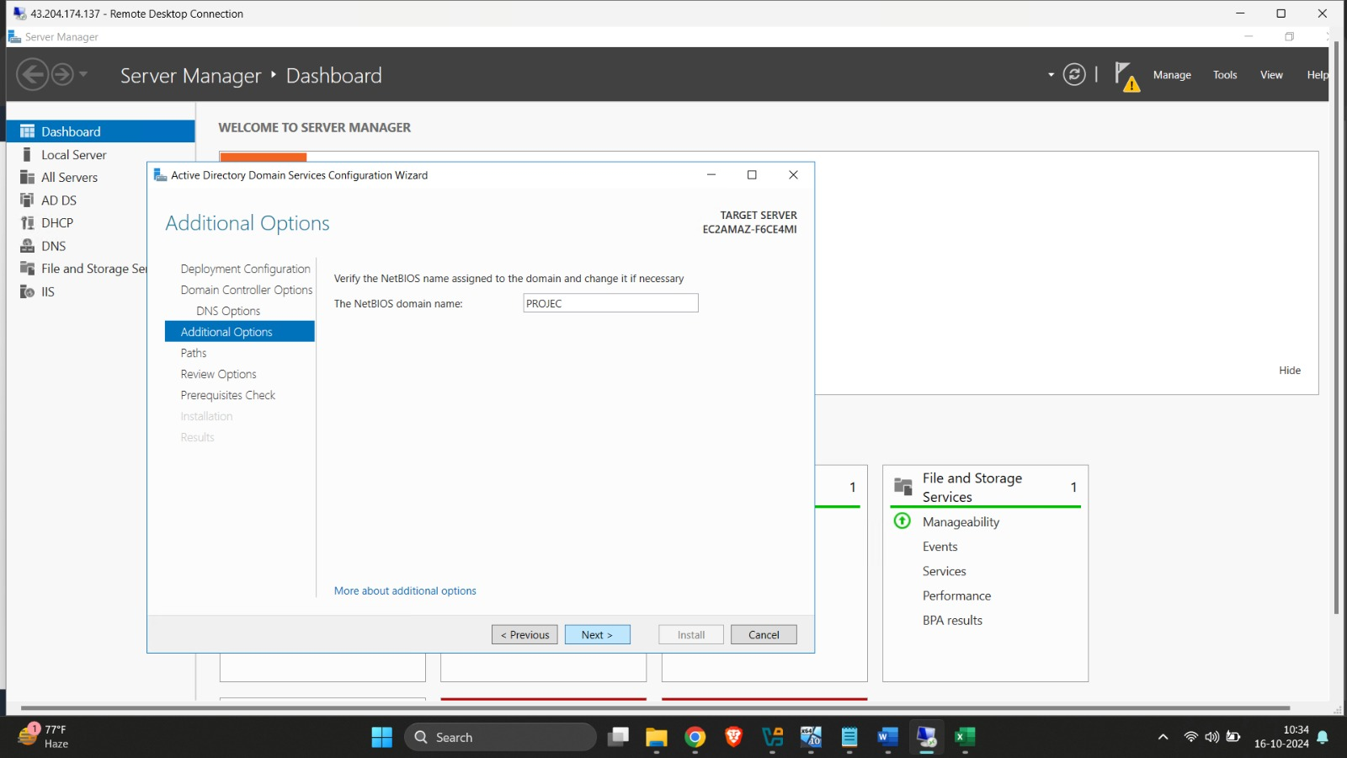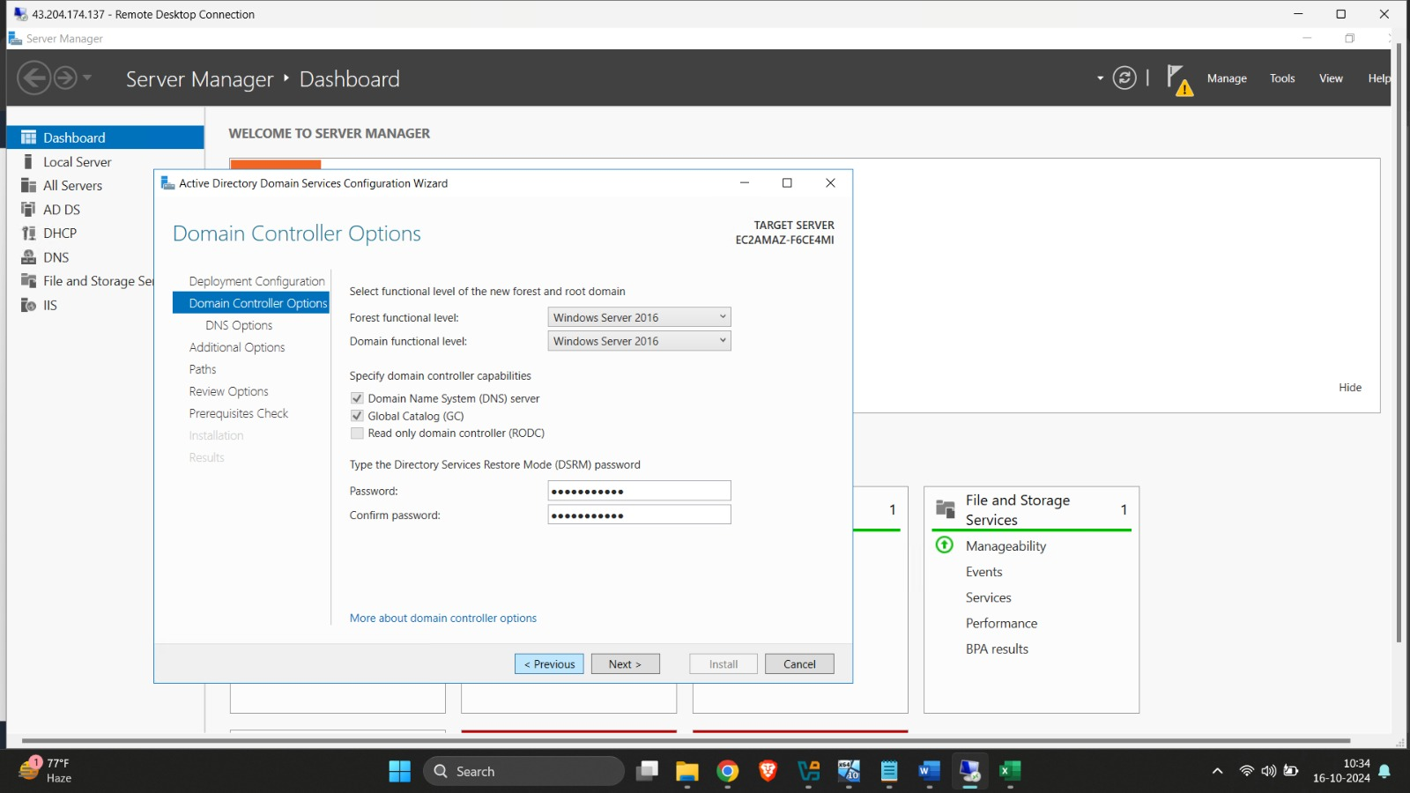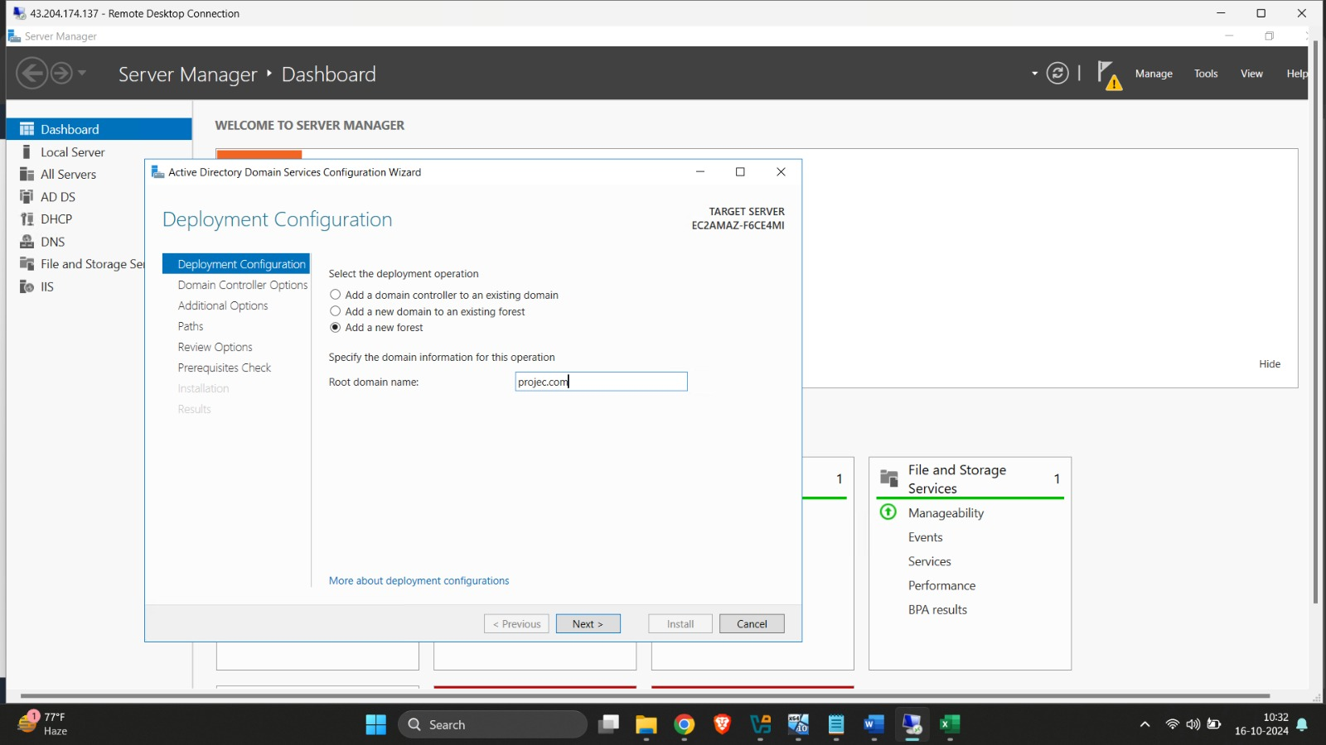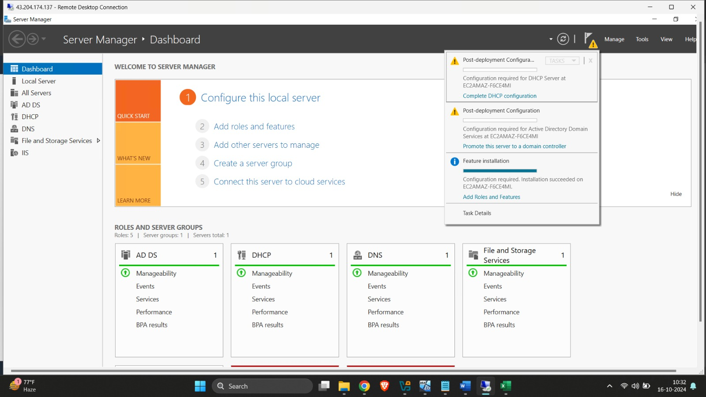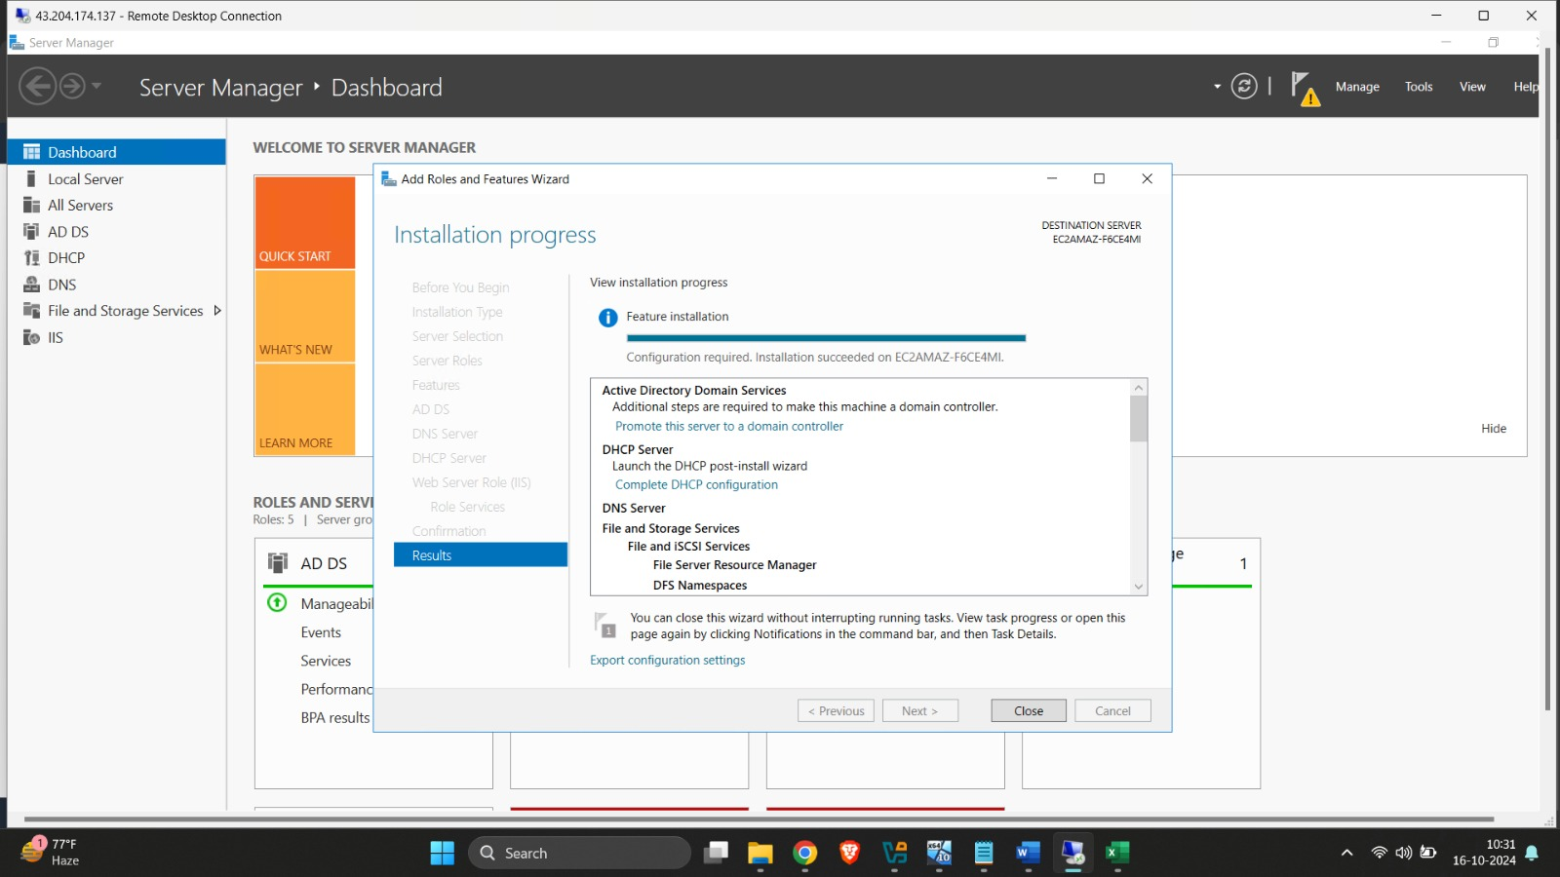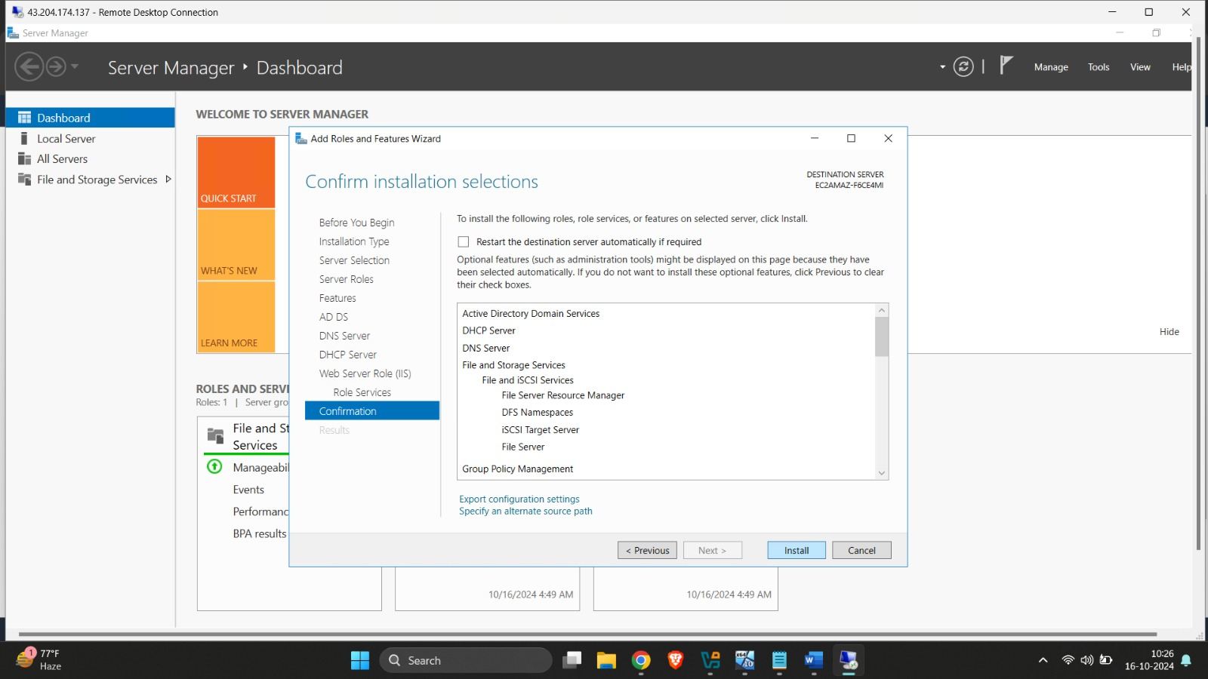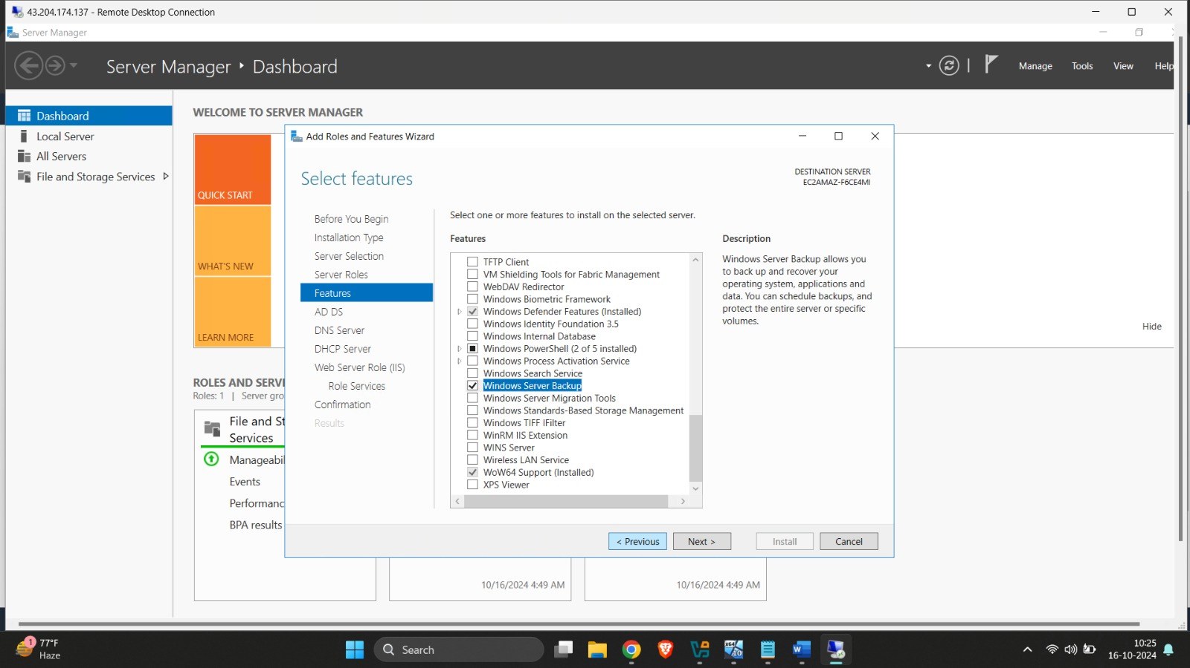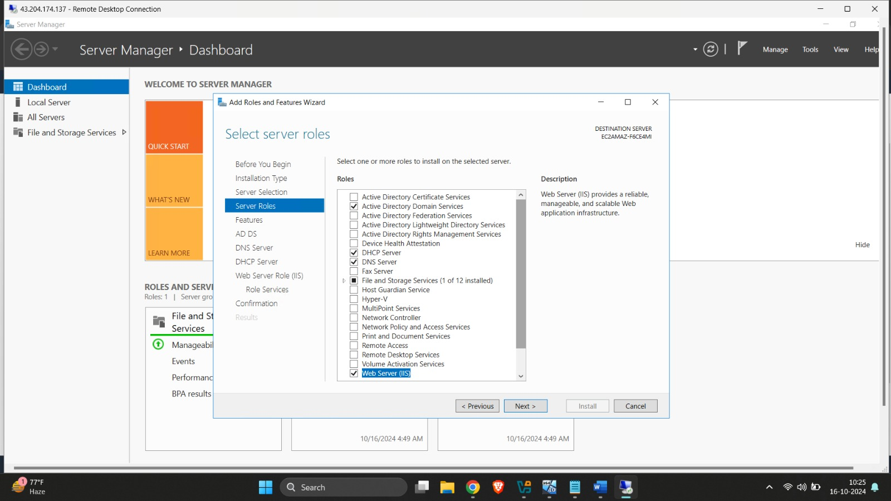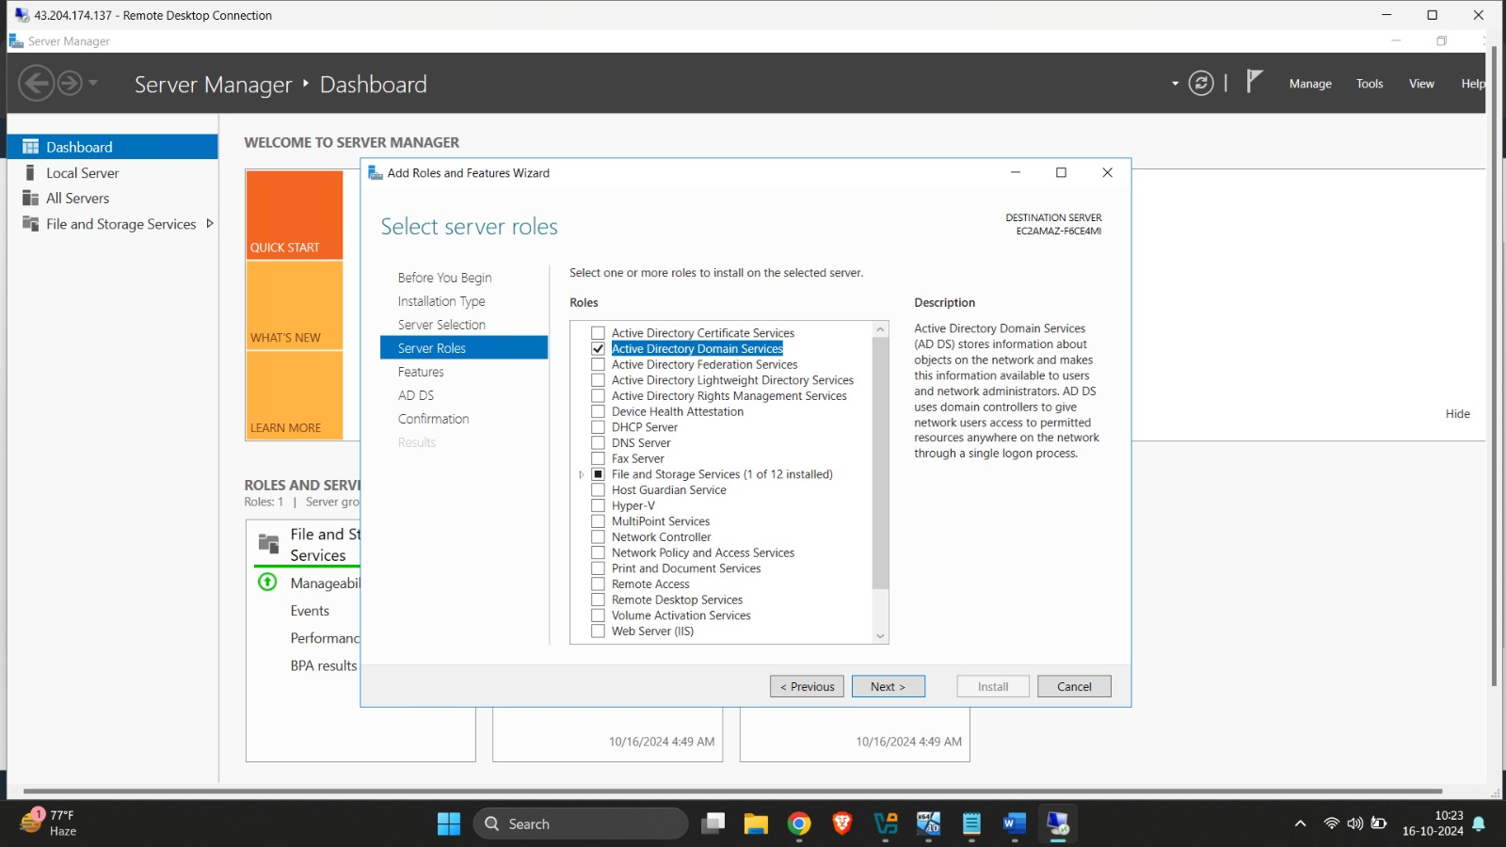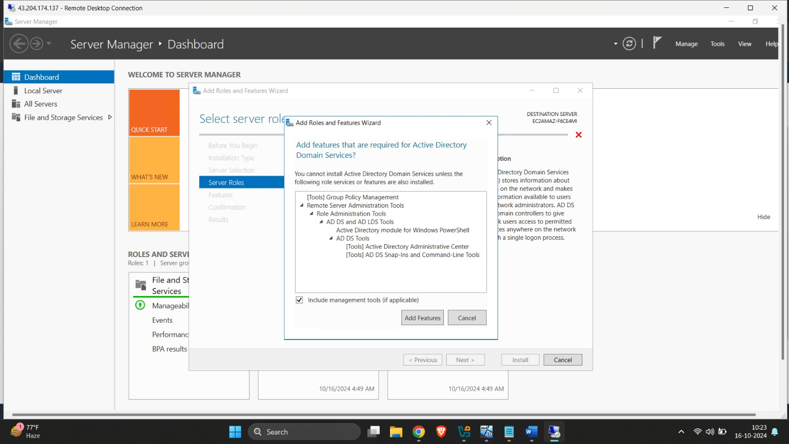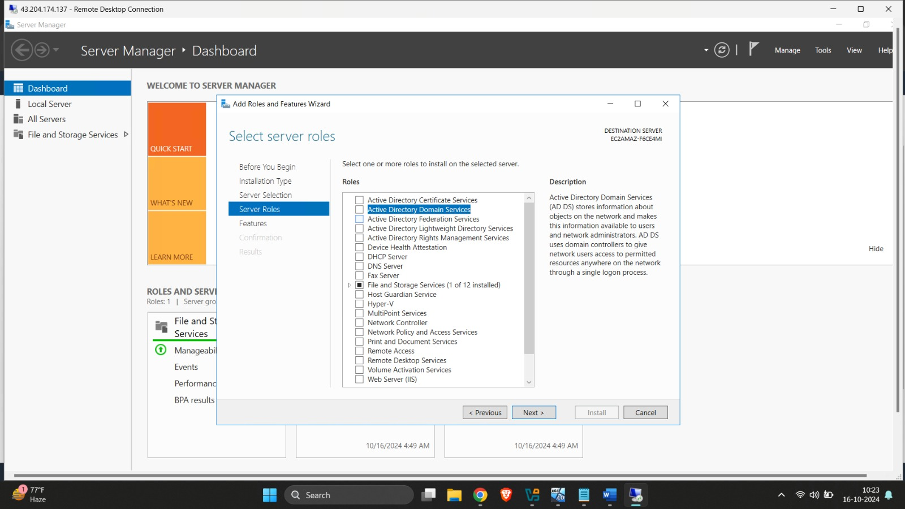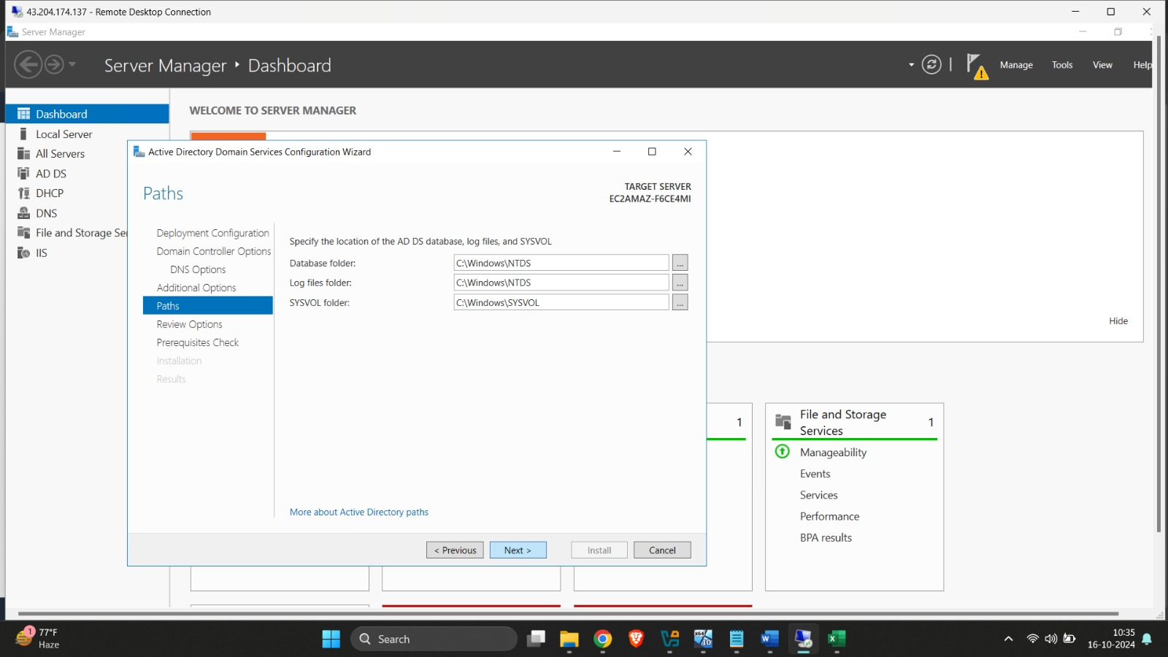

**2. DNS:**

To install, implement, and configure a test DNS service on a Windows Server 2016 EC2 instance using AWS, follow these steps:

**Step 1: Launch a Windows Server 2016 EC2 Instance**

1. Sign in to AWS Console and go to the EC2 Dashboard.

2. Launch a new EC2 instance:

- Choose Microsoft Windows Server 2016 Base AMI.

- Select the instance type (t2.medium or higher for moderate workloads).

- Configure a security group with the following rules:

- RDP: TCP on port 3389 (for remote desktop access).

- DNS: UDP and TCP on port 53 (for DNS queries).

- Launch the instance and save the private key file (for authentication purposes).

**Step 2: Connect to the EC2 Instance**

1. Use an RDP client to connect to the Windows Server 2016 instance. Use the public DNS/IP and the administrator credentials to log in.

2. After connecting, ensure the server is up to date with Windows updates.

**Step 3: Install DNS Server Role**

1. Open Server Manager:

- Click on Manage → Add Roles and Features.

- In the wizard, select Role-based or feature-based installation.

- Select the local server (the EC2 instance).

- Check the DNS Server role.

- Click Add Features when prompted to install the required features.

- Proceed through the wizard and click Install. The installation may take a few minutes.

**Step 4: Configure the DNS Server**

1. After installation, DNS tools will be available under Server Manager → Tools → DNS.

2. Open DNS Manager:

- Right-click the server name and select Configure a DNS Server to launch the configuration wizard.

**Step 5: Configure a Test DNS Zone**

1. In the DNS configuration wizard, select Create a forward lookup zone.

2. Choose Primary Zone for a single-server environment.

3. For the zone name, enter the domain name you want to use for DNS testing (e.g., `testdomain.com`).

4. Choose to Allow only secure dynamic updates (or no dynamic updates for testing purposes).

5. Complete the wizard and the zone will be created.

Step 6: Test the DNS Configuration

1. Open Command Prompt on the Windows Server or any machine connected to the same VPC as your EC2 instance.

2. Run the following command to test DNS resolution for the test domain:

nslookup www.testdomain.com

You should see a response showing the IP address you associated with the DNS record.

3. If the lookup fails, check:

- The security group settings of your EC2 instance to ensure UDP/TCP on port 53 is allowed.

- The DNS server settings to confirm the correct IP address and domain configuration.

**Step 7: Set the EC2 Instance as DNS for Other Instances**

1. To further test the DNS service, you can configure another EC2 instance to use the DNS server.

- Launch another EC2 instance and connect to it.

- In Network Adapter Settings, set the Preferred DNS Server to the private IP address of the DNS server instance.

2. Try resolving the DNS records (like `www.testdomain.com`) from this secondary instance using `nslookup`.

**Step 8: Final Testing and Validation**

- Test multiple types of DNS records to ensure your DNS service is functioning correctly.

- Optionally, configure DNS logging to monitor queries and troubleshoot potential issues.

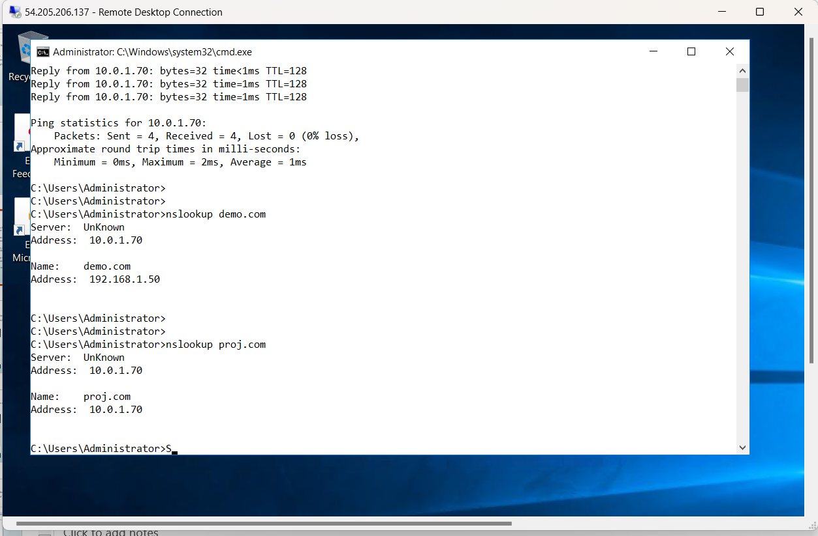

**3. File and Storage Service:**

Steps to Install and Implement File and Storage Services on Windows Server 2016 in AWS

**1. Launch and Access the Windows Server 2016 EC2 Instance**

Launch the EC2 instance:

Go to the EC2 Dashboard in the AWS Management Console.

Click Launch Instance and select Windows Server 2016 from the list of available AMIs (Amazon Machine Images).

Configure the instance settings as required (e.g., instance type, storage, network settings).

Configure Security Group:

When configuring the instance, create or modify the Security Group to allow inbound traffic on:

RDP (port 3389) for remote access.

SMB (ports 445 and 139) for file sharing, if you plan to access the file share from other instances or on-premises devices.

Allow outbound internet access for installation and updates.

Connect to the instance:

Once the instance is launched, connect to it via RDP (Remote Desktop Protocol) using the public IP or DNS provided by AWS.

**2. Install File and Storage Services Role**

Once you're connected to the Windows Server 2016 instance via RDP, follow these steps:

Open Server Manager:

Server Manager will typically open automatically on startup. If not, you can open it manually from the Start menu.

Add Roles and Features:

In Server Manager, click Manage > Add Roles and Features.

Select Installation Type:

Choose Role-based or feature-based installation, then click Next.

Select Server:

Choose the current server (your EC2 instance).

Select File and Storage Services Role:

Expand File and Storage Services.

Then expand File and iSCSI Services and select the following components based on your needs:

File Server (essential for sharing files).

DFS Namespaces, DFS Replication (for distributed file systems).

File Server Resource Manager (for quotas and file screening).

iSCSI Target Server (for shared storage).

Storage Replica (for disaster recovery).

Click Next and then Install to install the role.

Complete the Installation:

The installation will take a few minutes. Afterward, restart the server if prompted.

**3. Configure File and Storage Services**

Once the role is installed, you can configure the services:

a. Configure File Shares:

Open Server Manager:

Navigate to File and Storage Services > Shares.

Create a New Share:

Click Tasks > New Share to launch the wizard.

Choose a Share Profile:

Select the appropriate share profile (e.g., SMB Share - Quick for basic file sharing).

Set Share Location:

Select where to create the share. You can create it on the instance's EBS volumes (Elastic Block Store) or any other attached storage.

Set Permissions:

Configure access control (Read, Write, Full Control) for users or groups.

Finalize:

Review the settings and click Create to finalize the file share.

**4. Configure Storage (EBS, EFS)**

In AWS, you can attach additional storage to your Windows Server 2016 instance:

a. Elastic Block Store (EBS):

Add a new EBS volume:

Go to the EC2 Dashboard > Volumes and create a new volume.

Attach the volume to the Windows Server instance.

Format and mount the volume:

Inside the Windows instance, go to Disk Management, initialize the new disk, format it, and assign a drive letter.

You can use this volume to store file shares or any other application data.

b. Elastic File System (EFS) (optional for shared storage between instances):

Create an EFS:

Go to the EFS Dashboard in AWS and create a new EFS file system.

Mount the EFS:

Install the necessary drivers (Amazon EFS) on the Windows Server instance.

Mount the EFS file system to a local directory.

Use the mounted directory for file sharing across multiple instances.

**5. Accessing the File Share from Other Instances or Devices From Windows Clients:**

You can access the file shares using the EC2 instance's private IP or DNS name.

Format: \\Instance_Private_IP\ShareName.

From On-Premise Clients:

If you need to access the file share from an on-premise environment, ensure that you have set up VPN or AWS Direct Connect to establish secure connectivity.

**6. Enable Quotas and File Screening (Optional)**

If you installed File Server Resource Manager:

Open Server Manager > File and Storage Services > FSRM.

Configure quotas, file screening policies, and storage reports as needed to monitor and manage the file system.

**7. Monitoring and Managing File Services**

AWS provides various tools to monitor your Windows Server instance:

CloudWatch: Set up CloudWatch to monitor the performance and health of your EC2 instance.

CloudTrail: Track API calls and actions taken on your instance for security auditing.

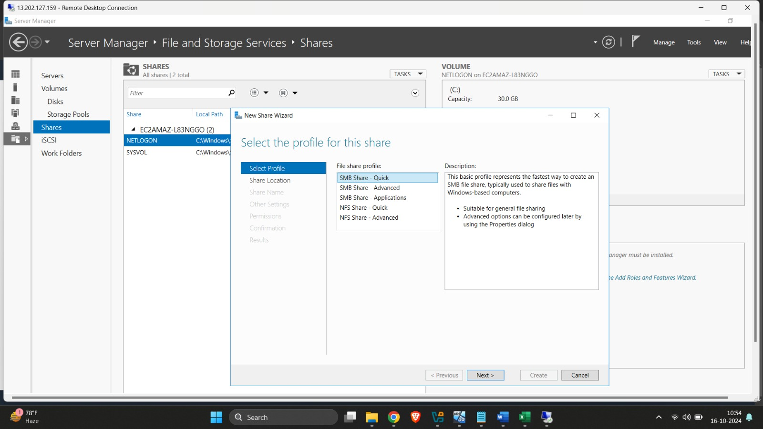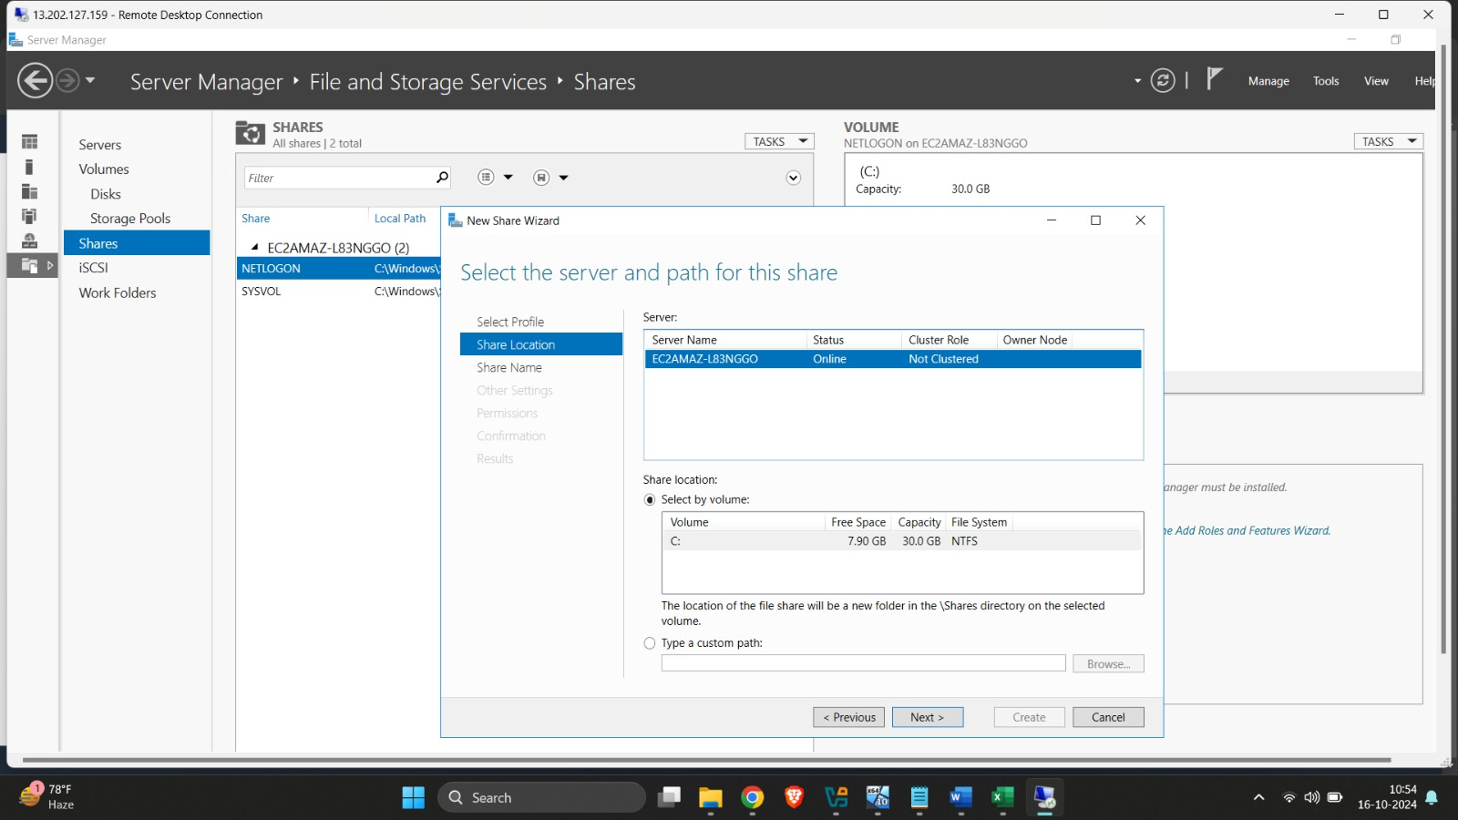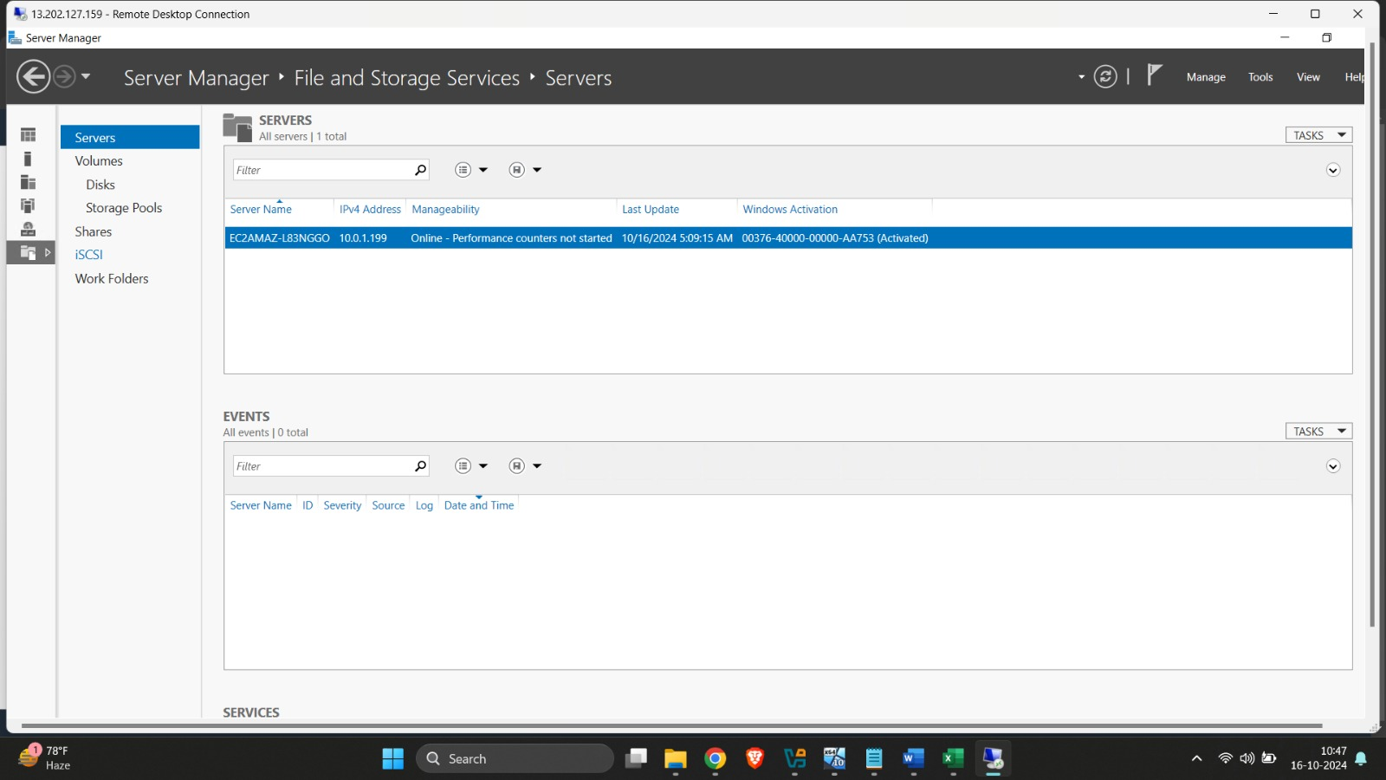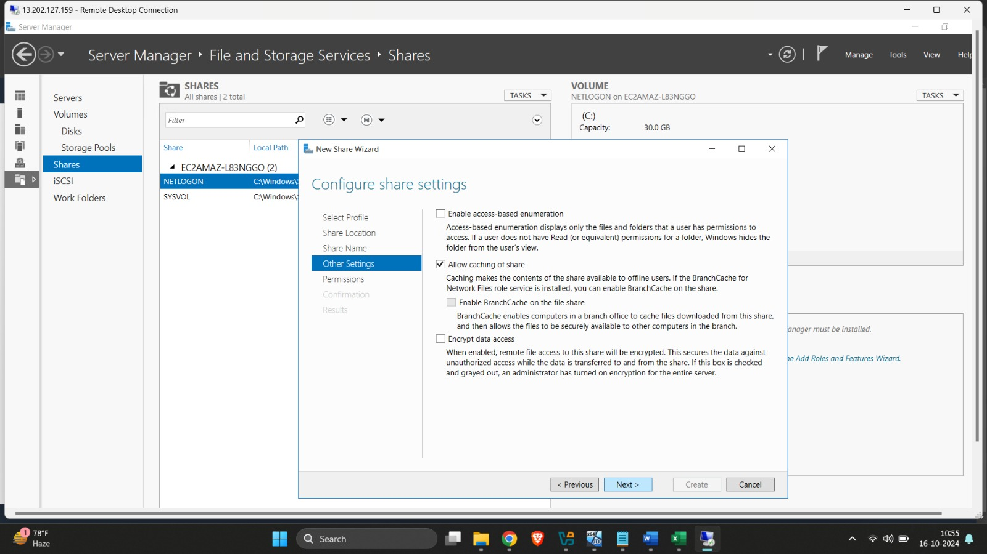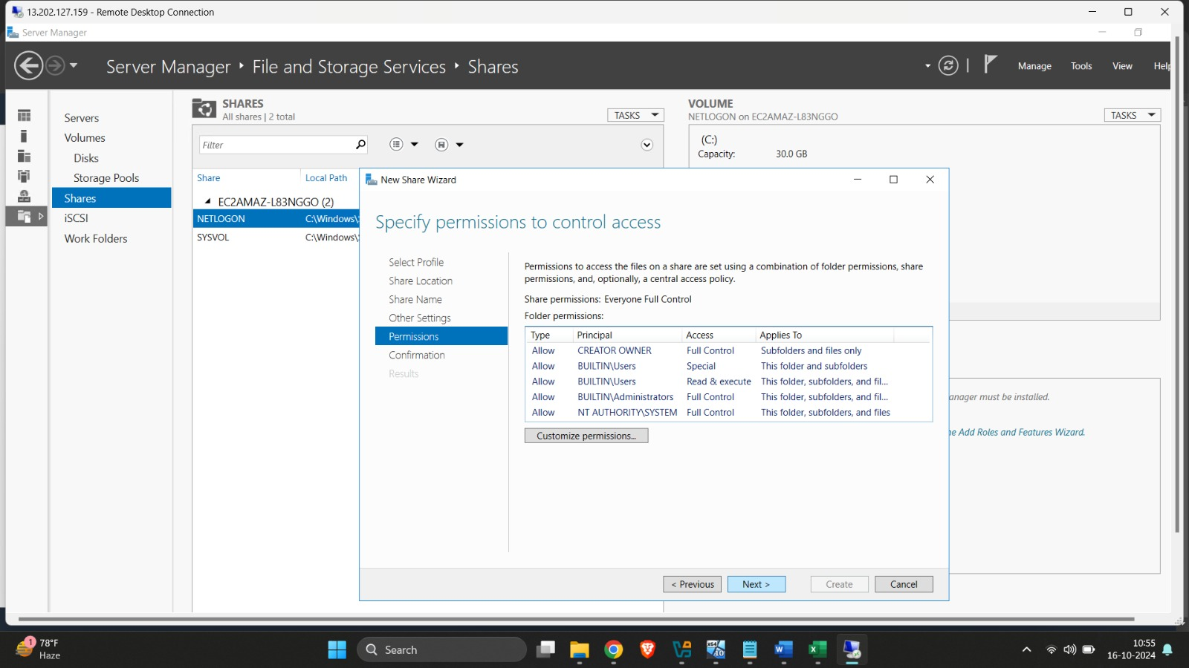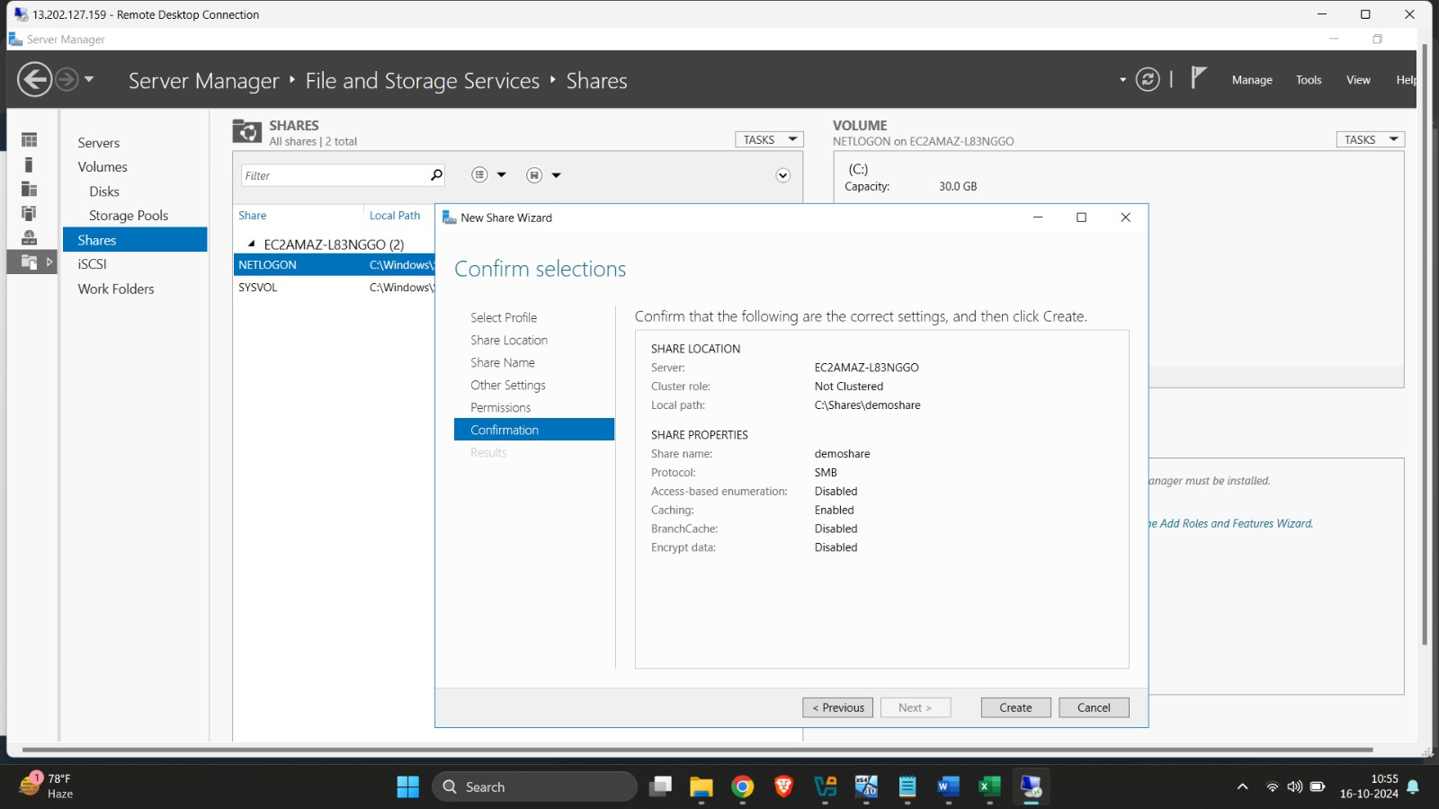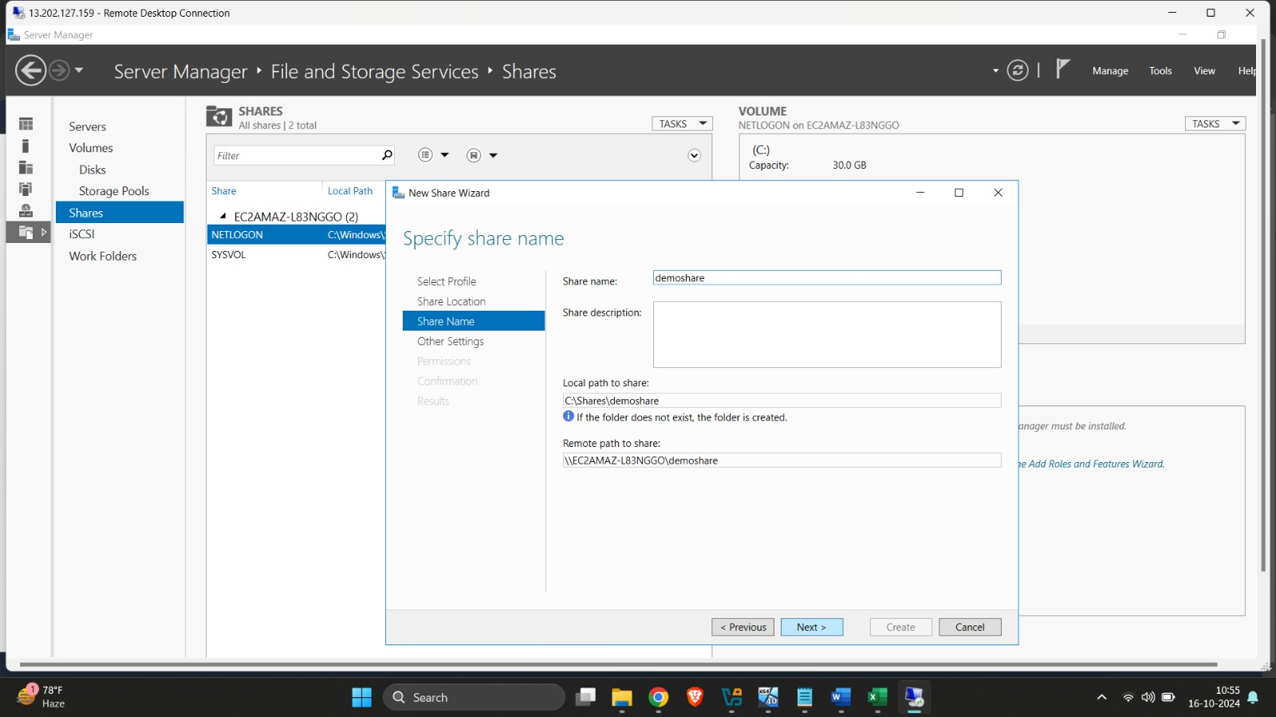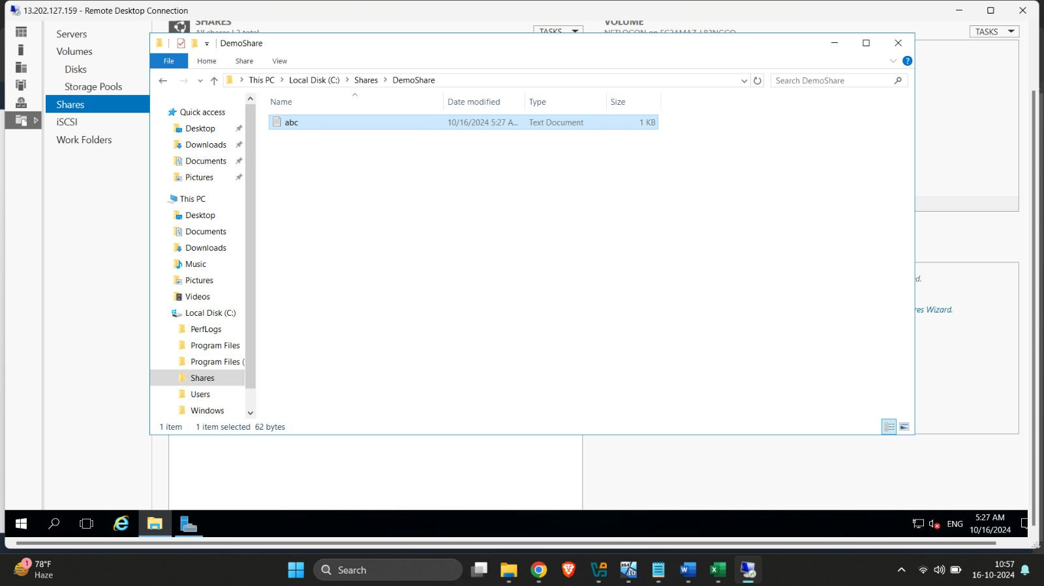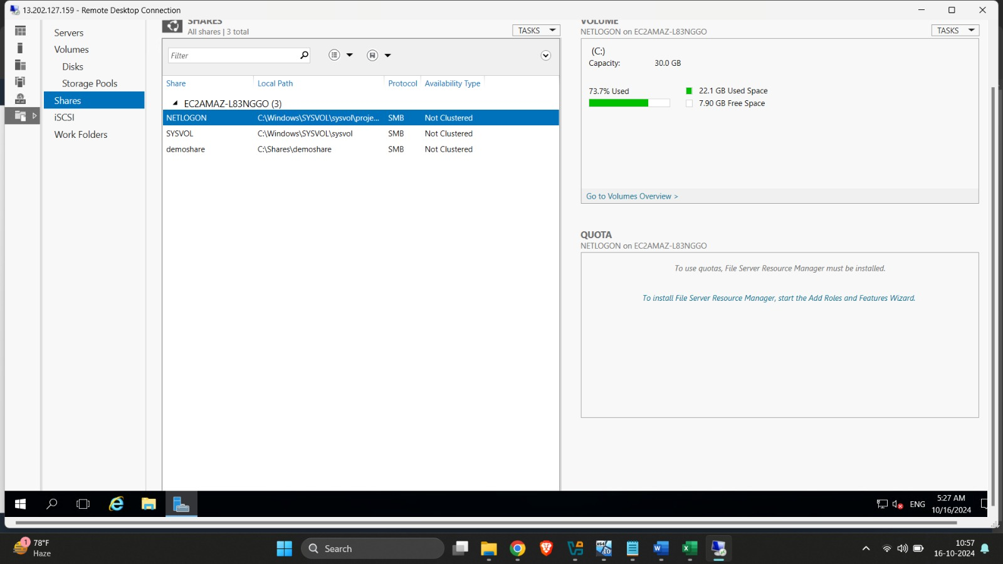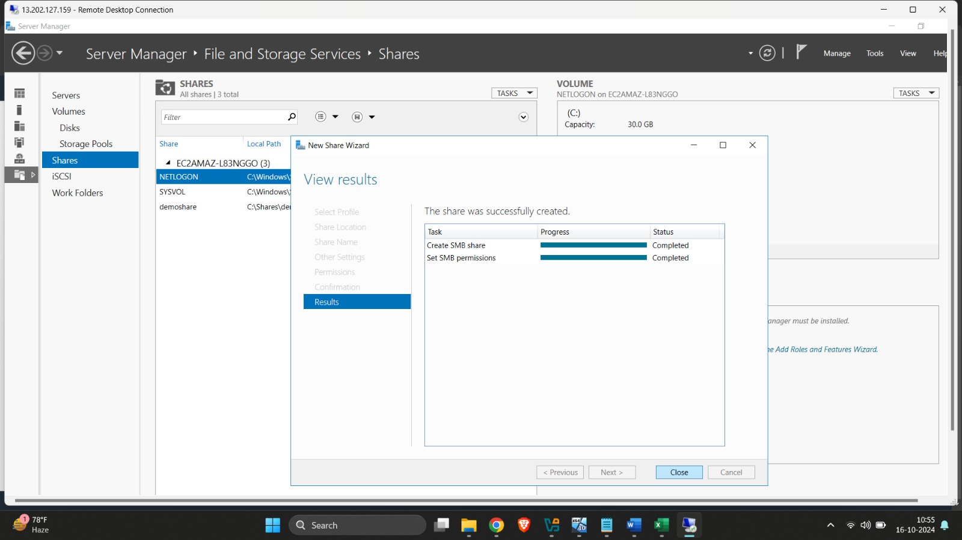

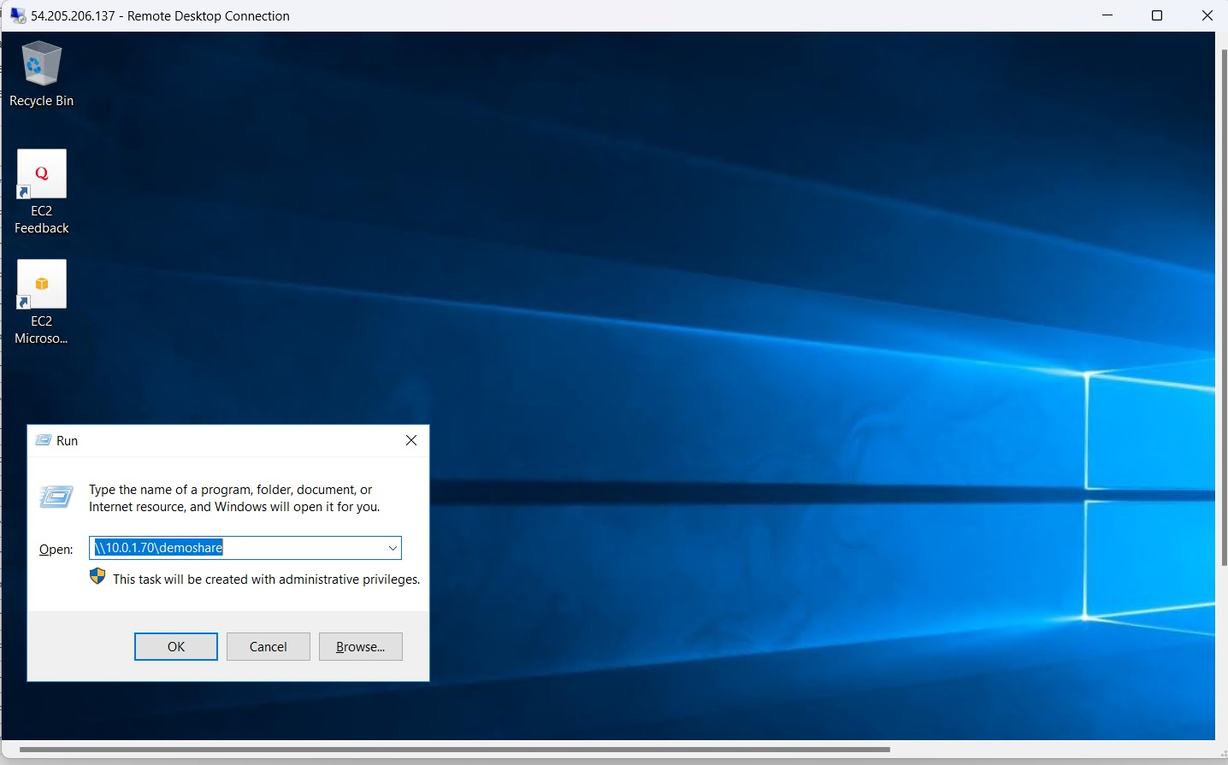

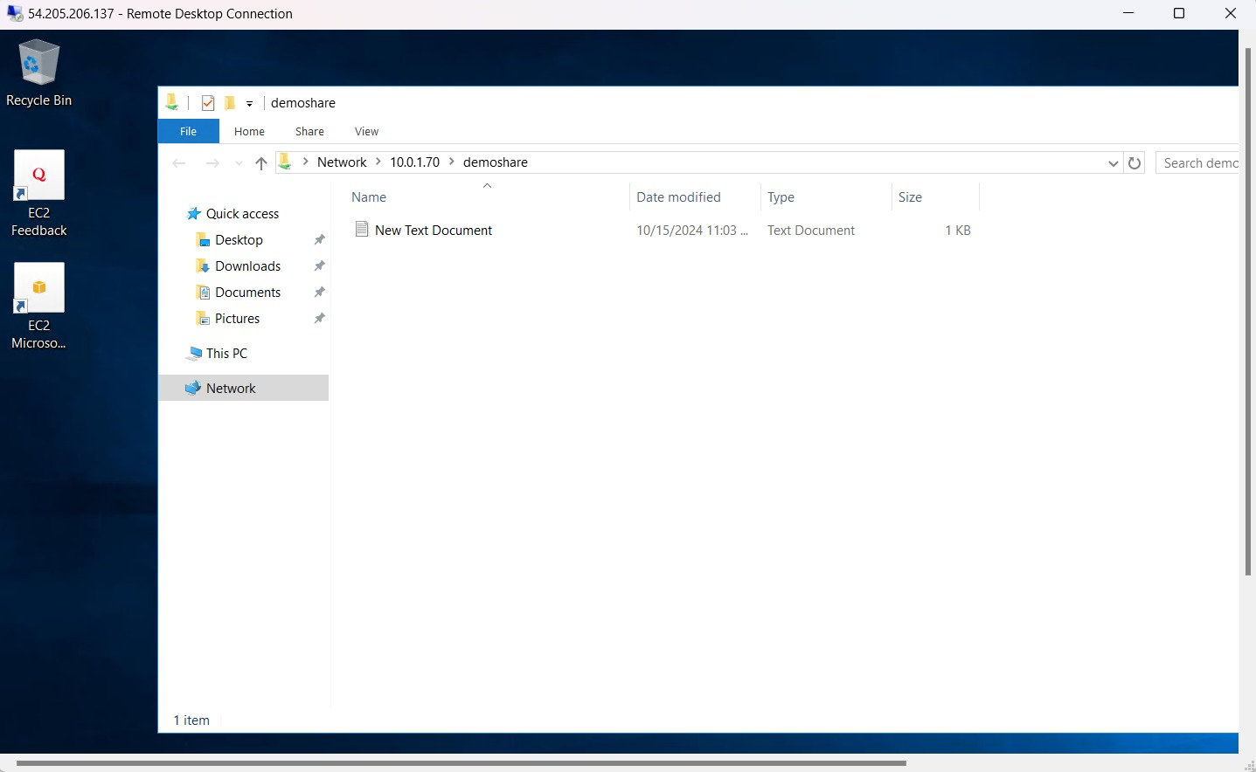

**4.Web Server(IIS):**

Configuring a web server on a Windows Server 2016 AWS instance involves several steps, including setting up the server, installing necessary roles, and ensuring that it can serve web pages. Here’s a step-by-step guide to help you configure a web server:

**1. Launch a Windows Server 2016 Instance on AWS**

Open the AWS Management Console.

Navigate to EC2 and click on Launch Instance.

Select Microsoft Windows Server 2016 as the operating system.

Choose an instance type (e.g., t2.micro if using the free tier).

Configure instance details, storage, and security group (make sure to allow HTTP (port 80) and HTTPS (port 443)).

Launch the instance and download the key pair for access.

**2. Connect to the Windows Server 2016 Instance**

In the AWS EC2 console, select your instance.

Click Connect and choose RDP.

Download and use the RDP file to connect to the instance using the public IP.

Use the password provided in the AWS console (decrypted using your key pair).

**3. Install IIS (Internet Information Services)**

IIS is the web server role on Windows that allows you to host websites and web applications.

Open Server Manager on your Windows Server 2016 instance.

Click on Add roles and features.

In the Add Roles and Features Wizard, follow these steps:

Click Next until you reach the Server Roles section.

Check the box for Web Server (IIS).

Click Next to include necessary features.

Click Next and then Install.

After installation, click Close.

**4. Configure IIS for Hosting Websites**

Open the IIS Manager from Server Manager.

In the Connections panel on the left, expand your server’s node and click on Sites.

You should see the default site (Default Web Site) running.

**5. Deploy a Website**

You can deploy a simple website by replacing the default content in the IIS root directory:

The default content is located in C:\inetpub\wwwroot.

Place your website's files (HTML, CSS, JavaScript, etc.) in this directory.

Ensure that your website is accessible by typing the public IP address of the instance into a web browser (http ://< public-ip>).

**6. Configure Security Groups**

Ensure that your security group allows inbound traffic on port 80 (HTTP) and port 443 (HTTPS) for SSL traffic.

You can configure this by navigating to Security Groups in the EC2 Management Console and adding these rules.

**7. Test the Web Server**

Open a browser and navigate to the public IP address of your EC2 instance (e.g., http ://< public-ip>).

If everything is configured correctly, you should see either the IIS default page or your custom website.

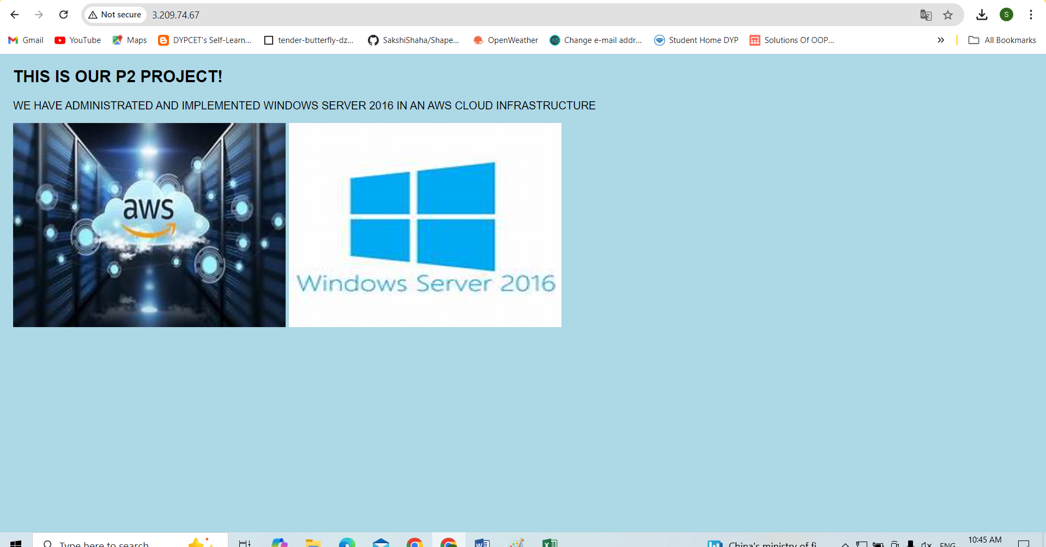

**Outputs of Monitoring Tools of AWS :**

**1.Cloudwatch:**

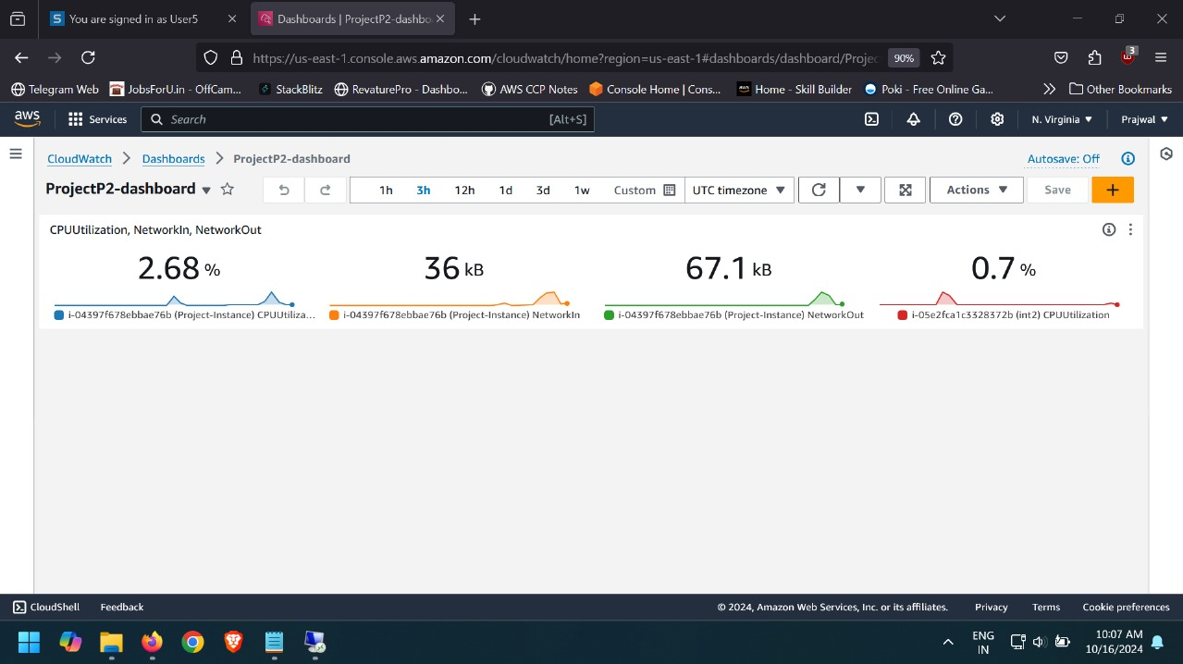

**2.Snapshots for Backup:**

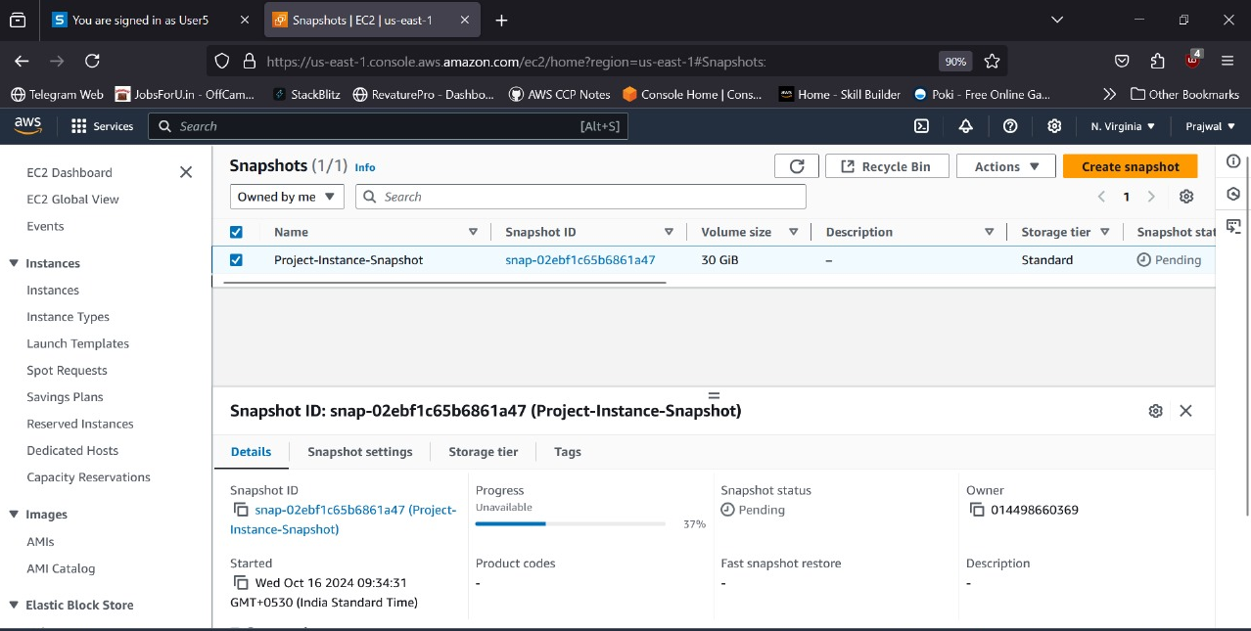

**3.Windows Performance Monitor :**

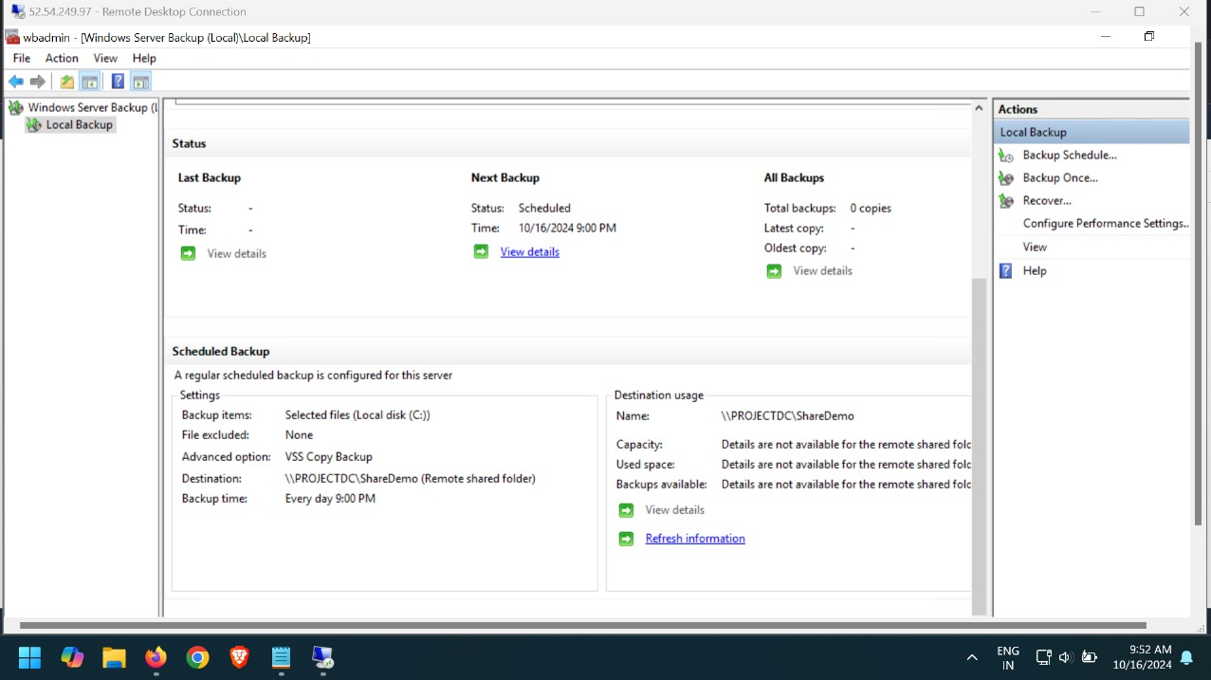

* **AutoScaling :**

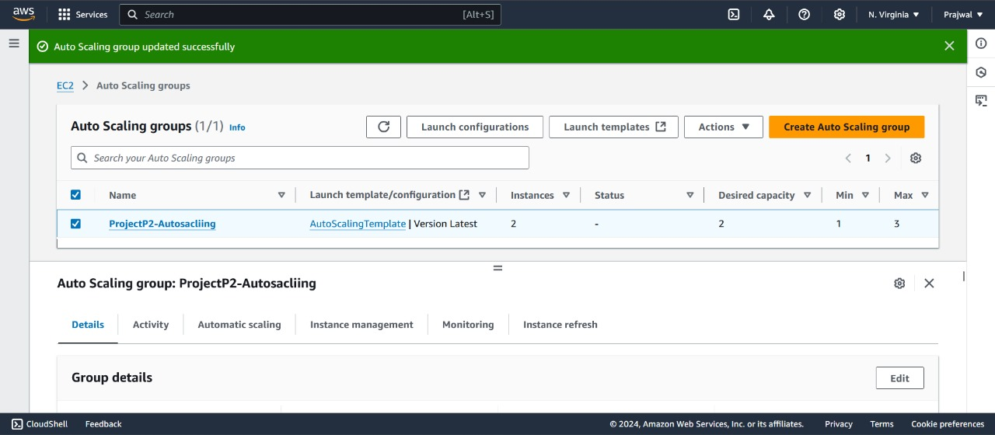

**Real Time Scenarios**

* **Scenario 1:** A small e-commerce company wants to move its on-premises web application to the cloud to improve scalability and reduce operational costs. The company currently runs its web application on a local server that struggles to handle peak traffic during sales events. They decide to implement Windows Server 2016 on AWS to leverage the cloud's flexibility and reliability.

**Outcome:**

By migrating to AWS, the e-commerce company successfully improved the scalability of its web application, enabling it to handle increased traffic during sales events. The cloud infrastructure provided enhanced security, reliable performance, and cost-effective resource management, ultimately leading to improved customer satisfaction and business growth.

* **Scenario 2:** A financial services company needs to host its internal applications and databases securely in the cloud to ensure high availability and compliance with regulatory standards. The company decides to migrate its existing on-premises Windows Server infrastructure to AWS, utilizing Windows Server 2016 to take advantage of cloud features.

**Outcome:**

The financial services company successfully migrated its internal applications to AWS, significantly improving the availability and reliability of its systems. The cloud infrastructure ensured compliance with regulatory standards, provided enhanced security measures, and facilitated efficient resource management, ultimately leading to a more agile and responsive IT environment.

* **Scenario 3:** A healthcare organization wants to migrate its patient management system to the cloud to improve accessibility for remote healthcare providers and ensure data security and compliance with regulations such as HIPAA. They choose to implement Windows Server 2016 on AWS to take advantage of the cloud's scalability and reliability.

**Outcome:**

The healthcare organization successfully migrated its patient management system to AWS, allowing remote healthcare providers to access patient data securely and efficiently. The cloud infrastructure not only improved accessibility but also ensured compliance with HIPAA regulations, provided high availability, and enabled effective monitoring and data protection, ultimately enhancing patient care and operational efficiency.

**Conclusion**

In conclusion, the administration and implementation of Windows Server 2016 within AWS Cloud Infrastructure have demonstrated significant advantages in scalability, security, and efficiency.

By leveraging key features such as Active Directory, DNS, DHCP, and web services, we created a robust environment that effectively meets organizational needs.

The use of backup solutions like AWS AMI and EBS snapshots ensures data integrity and rapid recovery in case of failures.

Additionally, our monitoring tools, including CloudWatch and Windows Performance Monitor, provide real-time insights into system performance, facilitating proactive management.

Overall, this project not only enhances resource management but also establishes a secure foundation for future cloud-based initiatives.

**Future Scope**

1. Migration to Newer Windows Server Versions: Future projects can focus on migrating to more recent versions of Windows Server (e.g., 2019 or 2022), ensuring improved performance, security features, and enhanced cloud integration capabilities.

2. Hybrid Cloud Integration: Expanding the infrastructure to a hybrid cloud model by integrating on-premises systems with AWS, allowing for seamless data exchange, enhanced disaster recovery, and greater flexibility in resource management.

3. Automation and Orchestration: Implementing AWS tools like AWS Systems Manager and CloudFormation to automate server management, patching, scaling, and resource deployment for more efficient operations.

4. Serverless and Containerization Solutions: Exploring the use of AWS Lambda or Docker containers to reduce dependency on virtual machines, enabling faster application deployment, scaling, and maintenance.5. Advanced Security Features: Leveraging AWS services such as AWS Shield and GuardDuty for enhanced threat detection, DDoS protection, and compliance with stricter security regulations.

6. Enhanced Monitoring and Analytics: Utilizing advanced analytics tools like Amazon Athena and AWS X-Ray to gain deeper insights into system performance, optimize resource utilization, and detect inefficiencies.

7. AI and Machine Learning Integration: Incorporating AWS AI/ML services for predictive monitoring and automated troubleshooting, further reducing manual intervention and increasing operational efficiency.